**JWG – proposal**

**ANNEX**

**to the**

**Implementing Regulation on interoperability requirements and non-discriminatory and transparent procedures for access to and exchange of data for demand response**

Table 1 3

Table 2 6

Table 3 7

Table 4 General access to Controllable Unit master data by an entitled party 13

Table 5 Controllable unit registration 14

Table 6 Update Controllable unit information 16

*Table 7 De-registration of CU* 18

*Table 8 Suspension of CU by an entitled party* 19

Table 9 Re-activation of CU 20

Table 10 Service provider registration 21

Table 11 Service provider application for qualification 23

Table 12 Service contract revocation by final customer 25

Table 13 Service contract termination by service provider 28

Table 14 29

Table 15SP Customer switching or new registration on CU 29

Table 16 Cancellation of SP registration on CU 34

Table 17 Update Service Provider profile information 37

Table 18 Update Service Provider critical information 37

Table 19 De-registration of Service Provider 39

*Table 20 Suspension of Service Provider qualification by System Operator* 40

*Table 21 Revocation of Service provider* 41

Table 22 Reactivation of Service provider 42

Table 23 SPU or SPG grid prequalification 43

Table 24 SPG or SPU product prequalification 44

*Table SPG or SPU product verification* 47

Table SPU or SPG registration 48

Table SPU or SPG update 49

Table SPU or SPG de-registration 50

Table 29 SPU or SPG re-activation 54

Table 30 General access to SPU or SPG master data by an entitled party 55

Table 31 Bidding and activation of active power flexibility product 56

Table 32 (conditional) Temporary limits 57

Table 33 (Optional) Baseline validation 64

Table **Table IV - Information objects exchanged**66

The reference model for data required for demand response.

The reference model for data required for demand response is composed of a set of reference procedures for access to data and the necessary information exchanges between roles acted by market participants relating to this specific case.

The tables in this Annex reflect this set of information that constitutes the reference model. The procedural steps that are set out may be combined or carried out in a different order when applied at the national level.

Table I contains information regarding the national market structure and environment. It is particularly useful to eligible parties that would like to set up their operation in the respective territory and utilise demand response data access in each Member State. This table must be read in conjunction with Commission Implementing Regulation (EU) 2023/1162 and Commission Implementing Regulation (EU) 2025/XXX. Table I is listing information that needs to be accessible for eligible parties to register, on-board or establish prerequisite infrastructure to take part in the procedures listed in Table III and accordingly communicate and exchange information with relevant market participants occupying the roles and undertaking the responsibilities indicated in Table II.

Some of the procedural steps described in Table III are marked as Conditional, it means that their implementation depends on the rules specified at national level..

When the steps as marked as optional, it means that the implementation depends on the objects they relate to [for some baselining methods, baseline validation does not need to go through all the steps].

Where the member state implementation defines a single entity taking on multiple roles, mapping and describing information exchanges between those roles, in effect within that entity, is not required.

If the member state implementation does not assign an aggregated role such as Entitled party or Affected party to any entity or entities for a specific procedure, mapping and describing such an information exchange is not required.

Table IV of the reference model defines a minimum set of attributes for each information object to ensure interoperability across Member States. These attributes may be extended at national level, for example to include the Balance Responsible Party (BRP) of the Service Provider, depending on national regulatory requirements and market design.

Table 1

|  |  |  |  |
| --- | --- | --- | --- |
| ***Table I – Additional general information on Member State environments for this Implementing Regulation*** | | | |
| ***ID*** | ***Name*** | ***Information*** | Description |
| I1 | Common access point | Name | Name of the organisation responsible for operating the common access point of the flexibility information system, as stated in NCDR. |
|  | Type of identification | ACER registration code, Legal Entity Identifier (LEI), Bank Identifier Code (BIC), Energy Identification Code (EIC), Global Location Number (GLN/GS1) or National Identification Code (NIC). |
|  | Identification of organisation | Code or identification of the organisation based on the types of identification mentioned in the previous field. |
|  | Website | Website of the common access point. |
|  | Onboarding for service providers for test environment | Description for how to onboard as a service provider. |
|  | Onboarding for service providers for production environment | Instructions for service providers to onboard to the production environment for the flexibility information system. |
|  | Data exchange standard(s) for the interaction with relevant market parties and systems. | List of data exchange standard(s) for the interaction with relevant market parties and systems. |
| I2 | CU module administrator(s) | Name | Name of the organisation responsible for a CU module. |
|  | Type of identification | ACER registration code, Legal Entity Identifier (LEI), Bank Identifier Code (BIC), Energy Identification Code (EIC), Global Location Number (GLN/GS1) or National Identification Code (NIC). |
|  | Identification of organisation | Code or identification of the organisation based on the types of identification mentioned in the previous field. |
|  | Website | Website of CU module administrator. |
|  | Area(s) | The area(s) defines the region(s) or grid area(s) over which the respective CU module administrator assumes operational responsibility. |
|  | Onboarding for test environment | Description of how to onboard to a test environment for the eligible parties. . |
|  | Onboarding for production environment | Description of how to onboard to the production environment for the entitled parties. |
|  | Data exchange standard(s) | List of data exchange standard(s) for the interaction with relevant market parties and systems. |
| I3 | SP module administrator(s) | Name | Name of the organization responsible for a SP module |
|  | Type of identification | ACER registration code, Legal Entity Identifier (LEI), Bank Identifier Code (BIC), Energy Identification Code (EIC), Global Location Number (GLN/GS1) or National Identification Code (NIC). |
|  | Identification of organisation | Code or identification of the organisation based on the types of identification mentioned in the previous field. |
|  | Website | Website of the SP module administrator |
|  | List of procuring System Operators and balancing or local services | List of procuring System Operators and concerned balancing or local services for which the bids and the activations are to be related to a SP and a SPU/PG registered in the SP module. |
|  | Onboarding for test environment | Description of how to onboard to a test environment for the elegible parties. |
|  | Onboarding for production environment | Description of how to onboard to the production environment for the entitled parties. |
|  | Data exchange standard(s) | List of data exchange standard(s) for the interaction with relevant market parties and systems. |
| I4 | Single access point for the publication of information related to market-based procurement of local services information | Website | Link to the single access point referred to in NCDR (Article 37 (7) ). |
|  | Operator of the access point | Party responsible for operating the single access point. |
|  | Data exchange standard(s) | Data exchange standard(s) to make available online and in a machine-readable manner published data. |
| I5 | Single access point for the publication of information related to the procurement of balancing services | Website | Link to the single access point for public information on balancing markets. |
|  | Operator of the access point | Party responsible for operating the single access point. |
|  | Data exchange standard(s) | Data exchange standard(s) to make available online and in a machine-readable manner published data. |
| I6 | National terms and conditions for baselining methods | Link | URL of the national website where the terms and conditions are published and consulted, and where updates are announced as defined in Article 5 (5) (a) of NCDR. |
| I7 | National terms and conditions for service providers | Link | URL of the national website where the terms and conditions are published and consulted, and where updates are announced as defined in Article 5 (5) (b) of NCDR. |
| I8 | National terms and conditions for flexibility information system | Link | URL of the national website where the terms and conditions are published and consulted, and where updates are announced as defined in Article 5 (5) (c) of NCDR. |
| I9 | Flexibility information system public data | Link | URL(s) of the online applications where free-to-access data within the flexibility information system is published. |
| I10 | Description of how the balance responsibility of the demand response services of the Service Provider is registered in the member state. | Link | URL(s) of the website that describe how the balance responsibility for providing demand response service is arranged and registered in the member state. |
| I11 | If applicable MS system for ~~'customer connection point~~ identification of ‘service validation point’  *(note: the point where the service delivery is validated)* | Name | National term for customer connection point ‘service validation point’ in the Member State language and as used in national documentation. |
| Identification system | Description of identification system(s) for ~~customer connection point~~ ‘service validation point’. *(One identification system per* ~~customer connection point~~ *service validation point needs to be mapped)* |
| I12 | MS system for ‘accounting point identification’ | Name | National term for ‘accounting point’ in the Member State language and as used in national documentation. |
| Identification system | Description of identification system(s) for accounting points’. *(One identification system per accounting point needs to be mapped)* |
| I13 | Information about service provider qualification requirements | Documentation | An accessible and comprehensive documentation on how the service provider can acquire a list of procuring system operators and corresponding product requirements for balancing and local services to be used when applying for service provider qualification. |
| I14 | Dedicated measurement device data administrator | Name | Name of the organisation responsible for the administration of the dedicated measurement device data. |
| Type of identification | ACER registration code, Legal Entity Identifier (LEI), Bank Identifier Code (BIC), Energy Identification Code (EIC), Global Location Number (GLN/GS1) or National Identification Code (NIC). |
| Identification of organisation | Code or identification of the organisation based on the types of identification mentioned in the previous field. |
| Website | Website of dedicated measurement device data administrator. |
| Onboarding for service providers for test environment | Description for how to onboard as a service provider. |
| Onboarding for service providers for production environment | Instructions for service providers to onboard to the production environment for the flexibility information system. |
| Data exchange standard(s) | List of data exchange standard(s) for the interaction with relevant market parties and systems. |
| I15 | Calculated data administrator | Name | Name of the organisation responsible for the administration of the calculated data. |
| Type of identification | ACER registration code, Legal Entity Identifier (LEI), Bank Identifier Code (BIC), Energy Identification Code (EIC), Global Location Number (GLN/GS1) or National Identification Code (NIC). |
| Identification of organisation | Code or identification of the organisation based on the types of identification mentioned in the previous field. |
| Website | Website of calculated data administrator. |
| Onboarding for service providers for test environment | Description for how to onboard as a service provider. |
| Onboarding for service providers for production environment | Instructions for service providers to onboard to the production environment for the flexibility information system. |
| Data exchange standard(s) | List of data exchange standard(s) |
| I16 | CU registration responsible party | Name | Name of the organisation responsible for CU registration. |
| Type of identification | ACER registration code, Legal Entity Identifier (LEI), Bank Identifier Code (BIC), Energy Identification Code (EIC), Global Location Number (GLN/GS1) or National Identification Code (NIC). |
| Identification of organisation | Code or identification of the organisation based on the types of identification mentioned in the previous field. |
| Website | Website of CU registration responsible party. |
| Onboarding for service providers for test environment | Description for how to onboard as a service provider. |
| Onboarding for service providers for production environment | Instructions for service providers to onboard to the production environment for the flexibility information system. |
| Data exchange standard(s) | List of data exchange standard(s) |
| I17 | Information about temporary limits applicability | Documentation | An accessible and comprehensive documentation on how the temporary limits are applied according to the national terms and conditions. |

Table 2

|  |  |  |
| --- | --- | --- |
| ***Table II – Roles*** | | |
| ***Role name*** | ***Role type*** | ***Role description*** |
| Final customer | Business | As defined in Article 2(3) of Directive (EU) 2019/944.  This refers to a party connected to the grid that purchases electricity for its own use.  **Note:** This also includes the case of active customer(s) and participants of renewable energy communities or citizen energy communities |
| Service provider | Business | As defined in Article 2 of NCDR. |
| CU module administrator | Business | A party responsible for storing and distributing CU master data within the flexibility information system |
| SP module administrator | Business | A party responsible for storing and distributing SP, SPUs and SPGs master data within the flexibility information system |
| Eligible party | Business | As defined in Article 2 of Commission Implementing Regulation (EU) 2023/1162 |
| Baseline calculator | Business | A party responsible for calculating the baseline of a resource according to a baselining method. |
| Baseline administrator | Business | a party responsible for storing and distributing baselines to entitled parties. |
| Metered data administrator | Business | As defined in Article 2 of Commission Implementing Regulation (EU) 2023/1162. |
| Metering point administrator | Business | As defined in Article 2 of Commission Implementing Regulation (EU) 2023/1162. |
| Connecting system operator | Business | As defined in Article 2 of NCDR |
| Procuring system operator | Business | As defined in Article 2 of NCDR |
| System operator | Business | As defined in Article 2 of NCDR |
| Quantification data aggregator | Business | A party responsible for the aggregation of validated historical metering and consumption data , near real-time metering and consumption data, DMD data or calculated data. This data is aggregated according to the terms and conditions pursuant to Article 11 of NCDR and pursuant to Article 18 of the Commission Regulation (EU) 2017/2195. |
| Quantification responsible party | Business | A party responsible for calculating the difference between the baseline and the corresponding metering, measurement or calculated data for a specific resource and a specific timeframe. |
| Dedicated measurement device data administrator or DMD data administrator | Business | ‘DMD data administrator’ or ‘dedicated measurement device data administrator’ means a party responsible for storing and distributing dedicated measurement device data as defined in Article 7b of Regulation (EU) 2019/943, as amended by Regulation (EU) 2024/1747 |
| Near real-time metered data administrator | Business | A party responsible for storing and distributing near real-time metering and consumption data from smart meter or smart metering system as defined in Commission Implementing Regulation (EU) 2023/1162 Art 2(5) |
| Calculated data administrator | Business | A party responsible for storing and distributing calculated data based on a formula depicting the electricity injection or withdrawal behaviour for a period. |
| CU registration responsible party | Business | A party entitled to interact with the CU module administrator to register, update and de-register CU master data on behalf of the final customer |
| Entitled party | Business | A party that must receive or send data because they are responsible for performing specific tasks according to the terms and conditions pursuant to Articles 11, 14 and 24 of NCDR, and pursuant to Article 18 of Commission Regulation (EU) 2017/2195. it is responsible for performing specific tasks according to the national terms and conditions pursuant to Articles 11, 14, 24 and 45 of NCDR and pursuant to Article 18 of the Commission Regulation (EU) 2017/2195. |
| Affected party | Business | A party that must be informed about the change of its responsibility as direct consequence of the execution of a referred procedure in this Implementing Regulation. This role can be assigned to one or more eligible parties based on national rules of the Member State and can differ in the different procedures. |
| Product prequalification responsible party | Business | A party performing a product prequalification as described in the Articles 18 and 20 of NCDR and in accordance with the national terms and conditions for service providers pursuant to Article 11 of NCDR. |
| Product verification responsible party | Business | A party performing a product verification as described in the Articles 18 and 19 and in accordance with the national terms and conditions for service providers pursuant to Article 11 of NCDR. |
| Activation test responsible party | Business | A party performing an activation test as described in the Articles 18, 19 and 20 of NCDR and in accordance with the national terms and conditions for service providers pursuant to Article 11 of NCDR. |
| Grid prequalification coordinator | Business | A party responsible to coordinate a grid prequalification as described in the national terms and conditions for TSO-DSO and DSO-DSO coordination pursuant to Article 45 of NCDR. |
| Temporary limit administrator | Business | A party responsible for storing and distributing temporary limits on system elements, SPUs, SPGs or parts of SPGs to entitled parties. |
| Service requiring responsible party | Business | A party responsible for validating the received bid messages, executing necessary actions to trigger the selection of bid[s] and communicating the selection and activation of bids. |
| Permission administrator for demand response |  | Permission administrator for demand response means a party responsible for administering data access permissions necessary for procedures defined in this Regulation and making the information about permissions available to final customers and eligible parties in the sector, on request |

All roles of type Business are expected to be acting in a secure, authenticated manner and through trusted communication channels. For this reason, the authentication steps used for these communication partners are not listed in the procedures below.

Table 3

|  |  |  |  |
| --- | --- | --- | --- |
| ***Table III - Procedure Overview*** | | | |
| ***No.*** | ***Procedure name / Description*** | ***Primary actor*** | ***Pre-condition*** |
| 1 | General access to Controllable Unit master data by an entitled party  *Describe information exchanges for the access to CU master data by an entitled party. The entitled party can be the CU registration responsible party or the service provider, and ask for master data related to all CUs for which it is an entitled party* | Entitled party | * The entitled party has the permission to access to the requested data in the flexibility information system. |
| 2 | Controllable Unit registration  *Describes information exchanges for the registration of a CU by the CU registration responsible party in the CU module of the flexibility information system.* *[as of NCDR, Article 28 (a)]* | CU registration responsible party | * The final customer informs the CU registration responsible party about his will to register a CU. * The CU registration responsible party obtains the necessary master data to trigger the registration of the CU. * The CU is linked to an accounting point and the accounting point ID is known. The link between the controllable unit and the accounting point is verified. * All needed permissions for access to data are given beforehand by the relevant data owners. |
| 3 | Update Controllable Unit information  *Describes information exchanges for the update of CU master data by the CU registration responsible party in the CU module of the flexibility information system.* *[as of NCDR, Article 28 (b)]* | CU registration responsible party | * The final customer informs the CU registration responsible party about his will to update a CU. * The CU registration responsible party obtains the necessary master data to trigger the update of the CU. * The resource to be updated must exist in the CU module. * CU registration responsible party has a valid permission from the final customer to update CU master data. |
| 4 | De-registration Controllable Unit  *Describes information exchanges for the de-registration of a CU by the CU registration responsible party from the CU module of the flexibility information system.* *[as of NCDR, Article 28 (d)]* | CU registration responsible party | * The CU to be de-registered must exist in the CU module. * The final customer informs the CU registration responsible party about his will to de-register a CU. * The CU registration responsible party obtains the necessary data to trigger the de-registration of the CU. * CU registration responsible party has a valid permission from the final customer to de-register a CU. |
| 5 | Suspension of Controllable Unit by an entitled party  *Describes information exchanges for the suspension of a CU by an entitled party according to national TERMS AND CONDITIONS in the CU module of the flexibility information system.* *[as of NCDR, Article 28 (c)]* | Party entitled to suspend a CU according to national terms and conditions | * Measures have been taken to avoid the need for suspension, but they were not sufficient. * The entitled party receives information about a needed CU suspension. * The entitled party obtains the necessary data to trigger the suspension of the CU. * The CU to be suspended must exist in the CU module. |
| 6 | Re-activation of Controllable Unit  *Describes information exchanges for the re-activation of a CU by a party entitled to re-activate a CU according to national terms and conditions in the CU module of the flexibility information system.* *[as of NCDR, Article 28 (i)]* | Party entitled to re-activate a CU according to national terms and conditions | * The service provider and the final customer are informed of the planned re-activation of the CU. * The entitled party obtains the necessary data to trigger the re-activation of the CU. * The resource to be re-activated must exist in the CU module. |
| 7 | Service Provider registration  *Describes information exchanges for the service provider registration process in the flexibility information system.*  *[as of NCDR, Article 27 (a)]* | Service provider | * The service provider has fulfilled all regulatory obligations to act as a service provider. |
| 8 | Service Provider application for qualification  *Describes information exchanges for when the service provider requests qualification to act as a service provider in the flexibility information system. The responsible system operator verifies that relevant requirements are fulfilled and approves the qualification.* | Service provider | * The service provider has completed the registration process. * The service provider knows for which procuring system operator and product they can request qualification (Table 1, I13). |
| 9 | Service contract revocation by Final Customer  *Describes information exchanges for when the final customer ends a contractual relationship with the service provider for a CU.*  *[as of NCDR, Article 28 (g)]* | Final customer | * A valid service contract exists between the final customer and the service provider. * The final customer has decided to revoke the contract and they have a valid reason to do so; or the final customer has lost entitlement to the CU, which leads to implicit contract revocation. |
| 10 | Service contract termination by Service Provider  *Describes information exchanges for when the service provider ends the contractual relationship with the final customer for a CU.*  *[as of NCDR, Article 28 (h)]* | Service provider | * A valid service contract exists between the final customer and the service provider. * The service provider has decided to terminate the contract, and they have a valid reason to do so. |
| 11 | SP Customer switching or new registration on CU  *Describes information exchanges for when the final customer and the service provider conclude a contract and the service provider registers itself for the final customer’s CU, possibly switching from a previous service provider.*  *[as of NCDR, Article 28 (f)]* | Service provider (new) | * CU has been successfully registered in the CU module. * SP has been registered and qualified to provide appropriate service. |
| 12 | Cancellation of SP registration on CU  *Describes information exchanges for when the contract between the final customer and the service provider is cancelled and the corresponding SP registration on CU is to be cancelled.* | Service provider (new) | * There exists a pending service provider request for registration in the CU module for on the CU based on agreed contract between the SP and the final customer. * The cancellation request is taking place before the starting date of the providing of the service and according to possible delay defined in the national arrangements. |
| 13 | Update service provider profile information  *Describes the information exchanges for when the service provider updates their basic profile information in flexibility information system*  *[as of NCDR, Article 27(c)]* | Service provider | * Service provider has previously registered in the SP module of the flexibility information system |
|  |  |  |  |
| 14 | De-registration of Service Provider | Service Provider | * Service provider has previously registered in the SP module of the flexibility information system * Service provider has no activated SPG or SPU |
| 15 | Suspension of Service Provider qualification by System Operator    *Describes information exchanges for the suspension of a SP by a Procuring System Operator or other assigned system operator according to national terms and conditions in the SP module of the flexibility information system.*  *[as of NCDR, Article 27 (d)]*  *The Procuring System Operator or other assigned system operator may only suspend the Service Provider in relation to the specific product for which the Service Provider has been qualified*  *The SP module operator may perform a separate suspension process applicable to Service Providers in general, triggered by circumstances such as revoked licenses or other significant events requiring a general suspension* | Procuring System Operator or other assigned system operator entitled to suspend a SP according to national terms and conditions | * The SP to be suspended must exist in the SP module and been approved by the Procuring System Operator or other assigned system operator * As a consequence of the SP suspension, related SPG or SPU cannot participate in balancing or local services |
| 16 | Revocation of service provider  Describes revocation of qualification status of a service provider by a Procuring System Operator | Procuring System Operator | * Service provider is qualified. * Procuring System Operator decided to revoke the qualification of the Service Provider for non-compliance with national Terms and Conditions for service providers. * The qualification of the service provider can be revoked regardless of active SPUs or SPGs. |
| 17 | Reactivation service provider  Describes re-activation after a temporary suspension of Service Providers product qualification. | System operator | * To reactivate a Service Provider after a suspension, the System Operator request a re-activation. * The SP Module administrator verifies and removes the suspension status and notifies the Service Provider and Entitled Parties. Information to Final Customer is conditional. |
| 18 | SPU or SPG registration  Describes information exchange covering service provider registering a SPU or SPG.  *[as of NCDR, Article 27(a)]* | Service provider | * The Service Provider is registered in the respective SP module |
| 19 | SPU or SPG update  Describes information exchange covering an authorized eligible party updating master data for a SPU or SPG and the SP module administrator notifying entitled parties about the update.  *[as of NCDR, Article 27(c)]* | Eligible party | * SPU or SPG is registered in the SP module. * Eligible party is authorized to request an update |
| 20 | SPU or SPG de-registration  Describes information exchange covering service provider de-registering a SPU or SPG.  *[as of NCDR, Article 27(e)]* | Service provider | * The Service Provider is registered in the respective SP Module * SPU or SPG is registered in the SP module. * SPU or SPG is not active in the bidding service or delivering services |
| 21 | SPU or SPG application  Describes information exchange covering SP registering an application for product qualification for a SPU or SPG and system operator confirming that the application is complete.  *[as of NCDR, Article 27(b)]* | Service provider | * Service provider is qualified and not suspended. * CU master data is registered in the respective CU modules * SPU or SPG master data is registered in the SP module. |
| 22 | SPU or SPG suspension  Describes information exchange used to suspend qualification of SPU or SPG by the relevant system operator.  *[as of NCDR, Article 27(d)]* | System operator | * SPU or SPG is registered in the respective SP module * System operator has determined or has received a request from another entitled party that the qualification status for a SPU or SPG should be suspended. |
| 23 | SPU or SPG re-activation  Describes information exchange used to reverse the suspension of qualification of SPU or SPG. | System operator | * The qualification for a SPU or SPG has been suspended by a system operator. * The system operator has determined or has received a request from another entitled party that the suspension of the qualification status for the SPU or SPG should be reversed. * Service provider is not suspended. |
| 24 | SPU or SPG grid prequalification  *Describes the data exchange for one grid prequalification*  *[as of NCDR, Article 27(f)]* | Grid prequalification coordinator | * Set of connecting and impacted system operators is known * The application process for the SPG or SPU – according to the national terms and conditions for service providers - is completed * SPU or SPG is registered in the SP module and has applied for market participation * All respective CUs are assigned to the SPU or SPG as of Article 18(1) the NCDR * An Entitled party has a valid reason to request Grid prequalification. The entitled party can be the SO (connecting or impacted or procuring SO), or the SP module administrator, or the SP. * The entitled parties have the knowledge of the characteristics of the related CUs of the SPU or SPG. |
| 25 | SPG or SPU product prequalification  Describes the data exchange related to one product prequalification. | Product prequalification responsible party | * The application process for the SPG or SPU – according to the national terms and conditions for service providers - is completed and a product prequalification is required * The product prequalification responsible party has valid reasons to initiate a product prequalification. * The SP is registered and qualified * SPU or SPG is registered in the SP module and has applied for market participation * All respective CUs are assigned to the SPU or SPG as of Article 18(1) the NCDR |
| 26 | SPG or SPU product verification  Describes the data exchange related to one product verification, after the delivery of the service. | Product verification responsible party | * The application process for the SPG or SPU – according to the national terms and conditions for service providers - is completed and a product verification is required, and thus the SPU or SPG is considered as temporary qualified * The SP is registered and qualified * The service is delivered by the service provider * The product verification responsible party has valid reasons to initiate a product verification. * SPU or SPG is registered in the SP module and has applied for market participation * All respective CUs are assigned to the SPU or SPG as of Article 18(1) the NCDR |
|  |  |  |  |
|  |  |  |  |
|  |  |  |  |
|  |  |  |  |
|  |  |  |  |
|  |  |  |  |
| 27 | General access to SPU or SPG master data by an entitled party | Entitled party | * The entitled party has the permission to access the requested data in the flexibility information system. |
| 28 | Bidding and activation of a active power flexibility product | Service acquiring responsible party | * Service provider is qualified * SPG, SPU of the SP is prequalified, or preliminarily qualified * The relevant information is in the FIS |
| 29 | Temporary limits | Relevant System Operator | * The relevant forecast data is available for relevant system operator and they performed an analysis that concluded a temporary limit has to be set or updated * Necessary information about the system elements, SPUs, SPGs or parts of SPGs for temporary limits are available |
| 30 | Baseline data handling  *Describes information exchanges required to establish an individual baseline by the baseline calculator and make it available for further use (baseline data stored by baseline administrator).* | Baseline calculator | * The Entitled Party has valid permission(s) to acquire and provide the data to the Baseline calculator * The resource or the group of resources provides demand response in a way that requires a baseline to be determined. * The baselining method for providing a service by the resource or the group of resources has been chosen. |
| 31 | Making measurement data available  *Describes the data exchanges to enable the Quantification data aggregator to get all the needed data from the relevant data administrator and be able to provide it for the quantification of the requested volume on different levels (CU, SPG or SPU, etc.)* | Quantification data aggregator | * The quantification data aggregator has the necessary permissions. * The quantification data aggregator has the necessary information to calculate the validated (aggregated) metered data. * The Quantification data aggregator is informed of the defined set of market rules for the aggregation of metering, a dedicated measurement device, or calculated data. |
| 32 | Quantification  *Describes the receipt of the data related to the activation and baseline, and the determination of the requested volumes on different levels (CU, SPG or SPU, etc.)* | Quantification responsible party | * The quantification responsible party is informed about the need for quantification (e.g., for an activated volume). * The quantification responsible party is aware of the relevant time interval for the quantification. |
| 33 | (Optional) Baseline Validation  *Describes the data exchanges potentially necessary to the validation of a baseline according to the chosen baselining method.* | Baseline validation responsible party | * Baseline validation responsible party is informed about the necessary information (purpose of validation) and appropriate activation period(s) for the validation process |

Information objects referred to in columns Information exchanged (IDs) are defined in Table IV. The steps in the scenarios might not always be executed as a complete, consecutive sequence. In some cases, it might be a collection of sub-sequences not necessarily dependent on each other.

|  |  |  |  |  |  |
| --- | --- | --- | --- | --- | --- |
| ***Table III.1 – Procedure 1*** | | | | | |
| ***Procedure name*** | | Table 4 General access to Controllable Unit master data by an entitled party | | | |
| ***Step No.*** | ***Step*** | ***Step description*** | ***Information producer (actor)*** | ***Information receiver (actor)*** | ***Information exchanged (IDs)*** |
| 1.1 | Request for CU master data | An entitled party requests to receive the CU master data for all the CUs that are registered in the Flexibility information system and linked to the requesting entitled party. | Entitled party | CU module administrator | A – CU master data request | |
| 1.2 | Validate CU master data request | The CU module administrator validates whether the information request is permitted or not and provides a meaningful indication[1] in case of an invalid request. | CU module administrator | Entitled party | B – Information on validation | |
| 1.3 | Send list of CU master data | The CU module administrator sends back the requested information from the flexibility information system. | CU module administrator | Entitled party | C – CU master data | |

Diagram 1 – Procedure ‘General access to CU master data by an entitled party’.

|  |  |  |  |  |  |
| --- | --- | --- | --- | --- | --- |
| ***Table III.2 – Procedure 2*** | | | | | |
| ***Procedure name*** | | Table 5 Controllable unit registration | | | |
| ***Step No.*** | ***Step*** | ***Step description*** | ***Information producer (actor)*** | ***Information receiver (actor)*** | ***Information exchanged (IDs)*** |
| 2.1 | Request CU registration | The CU registration responsible party sends the CU registration request to the CU module administrator. The request may include an existing identification code for the CU, if one exists. | CU registration responsible party | CU module administrator | D – CU registration request | |
| 2.2 | Validate CU registration request | The CU module administrator validates whether the information provided by the CU registration responsible party satisfies the registration needs. In case of an invalid request, it provides a meaningful indication. | CU module administrator | CU registration responsible party | B – Information on validation | |
| 2.3a | (Conditional – If required by national terms and conditions) Request permission | Request permission for the assignment of the CU and the sharing of relevant data with CU registration responsible party and other entitled parties on behalf of a final customer for (de-)registration and update purposes. | CU module administrator | Permission administrator for demand response | F - Permission validation request CU registration responsible party | |
| 2.3b | Validate permission | (Conditional) The permission administrator for demand response accepts the permission request on behalf of the final customer that relevant personal data is used for market processes and can be accessed by involved third parties.  **Note:** When mapping national practices, it is important to provide information on how the requesting party is informed about an accepted or rejected permission request. | Permission administrator for demand response | CU module administrator | F - Permission validation request CU registration responsible party | |
| 2.3c | Notify about permissions | Notify the CU registration responsible party about the permission given by the final customer to share CU master data.  **Note**: The permission shall be established similarly to Table III.2 in Annex of EC/2023/1162. | CU module administrator | CU registration responsible party | - | |
| 2.4 | Store CU Identification | The CU module administrator creates a new entry for the CU in the CU module. If the CU identification code was provided by the CU registration responsible party in step 2.1, that code should be used instead of creating a new code. | CU module administrator | [not relevant] | - | |
| 2.5 | Send CU identification | The CU module administrator sends the CU identification to the CU registration responsible party. | CU module administrator | CU registration responsible party | E – CU identification | |
| 2.6 | Send CU master data | CU registration is responsible for sending the necessary CU master data to the CU module administrator for the registration process.  Note: Notify grid prequalification coordinator to execute grid prequalification if necessary. | CU registration responsible party | CU module administrator | C – CU master data | |
| 2.8 | Notify about the registered CU module data | In case of a successful CU registration, the CU module administrator notifies the CU registration responsible party for the updated CU module information. | CU module administrator | CU registration responsible party | C – CU master data | |
| 2.9 | Notify about successful registration | The CU module administrator notifies the required entitled parties about the successful registration of a CU. | CU module administrator | Entitled parties | C – CU master data | |

Diagram 2 – Procedure ‘CU registration’.

|  |  |  |  |  |  |
| --- | --- | --- | --- | --- | --- |
| ***Table III.3 – Procedure 3*** | | | | | |
| ***Procedure name*** | | Table 6 Update Controllable unit information | | | |
| ***Step No.*** | ***Step*** | ***Step description*** | ***Information producer (actor)*** | ***Information receiver (actor)*** | ***Information exchanged (IDs)*** |
| 3.1 | Request CU update | The CU registration responsible party requests that the CU master data be updated.  **Note**: The CU registration responsible party sends the CU master data to be updated with the information object F. | CU registration responsible party | CU module administrator | C – CU master data |
| 3.2 | Validate CU update request | The CU module administrator validates whether the information provided by the CU registration responsible party is complete. In case of an invalid request, it provides a meaningful indication.  <Note for modelling: End process if the provided CU master data from the CU registration responsible party is not sufficient.>  Note: Notify grid prequalification coordinator to execute grid prequalification if necessary. | CU module administrator | CU registration responsible party | B – Information on validation |
| 3.3a | (Conditional – If required by national terms and conditions) Request permission | (Conditional) Request permission for the change of CU master data to the permission administrator on demand response on behalf of the final customer. | CU module administrator | Permission administrator for demand response | - |
| 3.3b | Validate permission | (Conditional) The permission administrator on demand response accepts the permission request on behalf of the final customer to change the CU master data.  **Note:** When mapping national practices, it is important to provide information on how the requesting party is informed about an accepted or rejected permission request. | Permission administrator for demand response | CU module administrator | - | |
| 3.3c | Notify about permissions | (Conditional) Notify the CU registration responsible party about the permission given by the final customer to change the CU master data.  **Note**: The permission shall be established similarly to Table III.2 in Annex of EC/2023/1162. | CU module administrator | CU registration responsible party | - | |
| 3.5 | Store updated master CU data | If the validation in step 3.4 was successful, the CU module administrator updates the CU master data in the CU module, and a timestamp indicating the latest update is set. | CU module administrator | [not relevant] | - |
| 3.6 | Notify about updated CU module information | In case of a successful controllable unit information update, the CU module administrator notifies the CU registration responsible party for updated CU module information. | CU module administrator | CU registration responsible party | C – CU master data |
| 3.7 | Notify about updated CU master data | In case of a successful CU information update, the CU module administrator notifies entitled parties about the updated CU master data.. | CU module administrator | Entitled party | C – CU master data |

Diagram 3 – Procedure ‘Update CU information’.

|  |  |  |  |  |  |
| --- | --- | --- | --- | --- | --- |
| ***Table III.4 – Procedure 4*** | | | | | |
| ***Procedure name*** | | *Table 7 De-registration of CU* | | | |
| ***Step No.*** | ***Step*** | ***Step description*** | ***Information producer (actor)*** | ***Information receiver (actor)*** | ***Information exchanged (IDs)*** |
| 4.1 | Request de-registration of CU | The CU registration responsible party requests the de-registration of a CU from the CU module. | CU registration responsible party | CU module administrator | G – CU de-registration request |
| 4.2 | Validate CU de-registration request | The CU module administrator validates if the CU fulfils the requirements to be de-registered. In case of an invalid request, it provides a meaningful indication. | CU module administrator | CU registration responsible party | B – Information on validation |
| 4.3 | De-register CU | The CU module administrator de-registers the CU directly or schedules a date for the de-registration. | CU module administrator | [not relevant] | - |
| 4.4 | Notify about CU de-registration | In case of a successful CU de-registration the CU module administrator sends the updated CU module information to the CU registration responsible party. | CU module administrator | CU registration responsible party | H – CU de-registration notification |
| 4.5 | Notify about CU master data update | In case of a successful CU de-registration the CU module administrator notifies the entitled parties About the updated CU master data. | CU module administrator | Entitled party | H – CU de-registration notification |

Diagram 4 – Procedure ‘De-registration of CU’.

|  |  |  |  |  |  |
| --- | --- | --- | --- | --- | --- |
| ***Table III.5 – Procedure 5*** | | | | | |
| ***Procedure name*** | | *Table 8 Suspension of CU by an entitled party* | | | |
| ***Step No.*** | ***Step*** | ***Step description*** | ***Information producer (actor)*** | ***Information receiver (actor)*** | ***Information exchanged (IDs)*** |
| 5.1 | Request suspension of CU | The entitled party sends the request for suspending a CU to the CU module administrator. | Entitled party | CU module administrator | I – CU suspension request |
| 5.2 | Validate CU suspension request | The CU module administrator validates the request and the entitlement of the requesting party to trigger the suspension. | CU module administrator | The party is entitled to suspend a CU according to national terms and conditions | B – Information on validation |
| 5.3 | Suspend CU | The CU module administrator suspends the CU in the CU module. | CU module administrator | [not relevant] | - |
| 5.4 | Notify about updated CU module data | If applicable, notify the service provider the CU is assigned. | CU module administrator | Service provider | J – CU suspension notification |
| 5.5 | (Conditional) Notify about suspended CU | (Conditional) Notify the final customer about CU suspension. | CU module administrator | Final customer | J – CU suspension notification |
| 5.6 | Notify other parties about CU suspension | The CU module administrator informs all affected parties of the suspension. | CU module administrator | Affected party | J – CU suspension notification |

Diagram 5– Procedure ‘Suspension of CU by an entitled party’.

|  |  |  |  |  |  |
| --- | --- | --- | --- | --- | --- |
| ***Table III.6 – Procedure 6*** | | | | | |
| ***Procedure name*** | | Table 9 Re-activation of CU | | | |
| ***Step No.*** | ***Step*** | ***Step description*** | ***Information producer (actor)*** | ***Information receiver (actor)*** | ***Information exchanged (IDs)*** |
| 6.1 | Request re-activation of CU | The entitled party requests re-activation of a CU to the CU module administrator.  The party entitled to re-activate a CU as defined in the national terms and conditions for the flexibility information system (e.g., connecting and procuring system operators, etc.). | Entitled party | CU module administrator | K – CU re-activation request |
| 6.2 | Validate CU re-activation request | The CU module administrator validates the request and the entitlement of the requesting party to trigger the re-activation.  Note: Notify grid prequalification coordinator to execute grid prequalification if necessary. | CU module administrator | Entitled party | B – Information on validation |
| 6.4 | Re-activate CU | The CU module administrator re-activates the CU in the CU module. | CU module administrator | [Not relevant] | - |
| 6.5 | (Conditional) Notify about re-activated CU | (Conditional) Notify the final customer about CU re-activation. | CU module administrator | Final customer | L – CU re-activation notification |
| 6.6 | Notify other parties about CU re-activation | The CU module administrator informs all affected parties of the re-activation. | CU module administrator | Affected party | L – CU re-activation notification |
| 6.7 | Notify about updated CU module information | The CU module administrator informs the entitled parties of the re-activation. | CU module administrator | Entitledparty | L – CU re-activation notification |

Diagram 6 – Procedure ‘Re-activation of CU.’

|  |  |  |  |  |  |
| --- | --- | --- | --- | --- | --- |
| ***Table III.7 – Procedure 7*** | | | | | |
| ***Procedure name*** | | Table 10 Service provider registration | | | |
| ***Step No.*** | ***Step*** | ***Step description*** | ***Information producer (actor)*** | ***Information receiver (actor)*** | ***Information exchanged (IDs)*** |
| 7.1 | Request registration | The SP applies for access (account) for the flexibility information system. The service provider may choose to register with an existing identification code if they have previously received an identification code that is valid according to the national terms and conditions. Otherwise, they can request and receive a new identification code. | Service provider | SP module operator | M – Service provider registration request | |
| 7.2 | Validate registration request | The SP module operator validates whether the service provider is eligible for being granted access to the flexibility information system and provides a meaningful indication in case of an invalid request. | SP module operator | Service provider | B – Request  validation  information | |
| 7.3 | Send credentials | In case of a positive validation of the access request, the SP module operator sends back the credentials to the service provider, including a unique identification code for the service provider. | SP module operator | Service provider | N – Service provider identification information | |
| 7.4 | Request update of profile information | The SP sends their generic profile information, not including product-specific information to the SP module operator. | Service provider | SP module operator | O – Service provider profile information | |
| 7.5 | Validate the request to update profile information | The SP module operator validates the completeness of the updated information and provides a meaningful indication in case of an invalid request. | SP module operator | Service provider | B – Information on validation | |
| 7.6 | Validate profile | The SP module operator validates the correctness of the provided profile information. | SP module operator | Service provider | B – Information on validation | |
| 7.7 | Notify about successful SP registration | The SP module operator informs the service provider about the result of their registration. | SP module operator | Service provider | P – Service provider registration confirmation | |
| 7.8 | Notify about new registered service provider | The SP module operator notifies relevant entitled parties about the successful registration of the service provider. | SP module operator | Entitled party | O – Service provider profile information | |

Diagram 7 – Procedure ‘Service provider registration’.

|  |  |  |  |  |  |
| --- | --- | --- | --- | --- | --- |
| ***Table III.8 – Procedure 8*** | | | | | |
| ***Procedure name*** | | Table 11 Service provider application for qualification | | | |
| ***Step No.*** | ***Step*** | ***Step description*** | ***Information producer (actor)*** | ***Information receiver (actor)*** | ***Information exchanged (IDs)*** |
| 8.1 | Request service provider qualification | The SP requests for service provider qualification in the Flexibility Information System with the required product-specific information. | Service provider | SP module operator | Q – Request for service provider qualification | |
| 8.2 | Validate qualification request | The SP module operator validates whether the request is valid and provides a meaningful indication in case of an invalid request. | SP module operator | Service provider | B – Information on validation | |
| 8.3 | Register service provider qualification request | The SP module operator registers the service provider qualification process in the initial status. | SP module operator | [not relevant] | [not relevant] | |
| 8.4 | Request to process service provider application for qualification | The SP module operator forwards a new service provider application for qualification to the relevant Procuring system operator or other assigned system operator and provides the service provider’s registered data to the procuring system operator. | SP module operator | Procuring system operator | Q – Request for service provider qualification | |
| 8.5 | Execute qualification | The Procuring System Operator or other assigned system operator initiates the qualification process, checking whether the requirements described in Article 17 of NCDR and possible other relevant conditions are met.  The Procuring System Operator checks whether the service provider is already qualified to provide another balancing or local product or the same product to another system operator. In these cases, a simplified qualification process should be applied, as described in Art 17(2) and 17(3) of NCDR.  **Note**: This step may require information exchange that is not within the scope of this procedure. | Procuring System Operator | [not relevant] | [not relevant] | |
| 8.6 | Update status when changed | During the qualification process, the Procuring System Operator or other assigned system operator updates SP module with status of the qualification process. | Procuring System Operator | SP module operator | R – Service provider qualification status update | |
| 8.7 | Acknowledge the updated status | The SP module operator acknowledges the updated qualification status back to the procuring system operator or other assigned system operator, or a meaningful indication in case of a problem in the status update. | SP module operator | Procuring System Operator | B – Information on validation | |
| 8.8 | Register updated status | The SP module operator registers the update status for the service provider qualification process. | SP module operator | [not relevant] | [not relevant] | |
| 8.9 | Notify qualification status | The SP module operator notifies the Service Provider when the qualification status is updated.  **Note**: If the qualification process is not finished, the process loops back to step 8.5. | SP module operator | Service provider | R – Service provider qualification status update | |

Diagram 8 – Procedure ‘Service provider application for qualification’.

|  |  |  |  |  |  |
| --- | --- | --- | --- | --- | --- |
| ***Table III.9 – Procedure 9*** | | | | | |
| ***Procedure name*** | | Table 12 Service contract revocation by final customer | | | |
| ***Step No.*** | ***Step*** | ***Step description*** | ***Information producer (actor)*** | ***Information receiver (actor)*** | ***Information exchanged (IDs)*** |
| 9.1 | Request contract termination | The final customer informs their service provider that they want to terminate the existing contract on a certain termination date.  **Note**: This is the main starting point of the procedure | Final customer | Service provider | S – Contract termination request | |
| 9.2 | Validate and acknowledge contract termination request | The service provider validates the request and provides either a meaningful indication of an invalid request or an acknowledgement of a valid request. | Service provider | Final customer | B – Information on validation | |
| 9.3 | Request to remove the assignment of the CU | The service provider informs the flexibility information system CU module that the linking between the SP and CU should be terminated on the given termination date. | Service provider | CU module administrator | T – CU assignment data | |
| 9.4 | Validate explicit request to remove assignment of the CU | The CU module administrator validates the request and confirms that the request to remove the assignment of the CU is being processed or provides a meaningful indication of an invalid request. | CU module administrator | Service provider | B – Information on validation | |
| 9.5 | Request to process change  of accounting  point  entitlement  (implicit) | External reasons (for example, a move-out) lead to an invalidation of the entitlement of a final customer to an accounting point and implicit contract termination. The metering point administrator informs the CU module administrator about these events.  **Note**: This is an alternative starting point for the procedure. | Metering point administrator | CU module administrator | U – Accounting point entitlement notification | |
| 9.6 | Validate request to process change of accounting point entitlement | The CU module administrator validates that the request to trigger implicit contract termination is technically correct. In case of an invalid request, a meaningful indication should be provided. | CU module administrator | Metering point administrator | B – Information on validation | |
| 9.7 | Execute removal of CU assignment | The CU module administrator removes the assignment of the CU from the service provider. | CU module administrator | [not relevant] | [not relevant] | |
| 9.8 | Notify about removal of CU from service provider | The CU module administrator notifies entitled parties that the CU has been removed from the service provider.  Note:  The SP module administrator is notified as an entitled party about the need to make the appropriate change in the SPU or SPG master data | CU module administrator | Entitled parties | V – CU removal notification | |
| 9.9 | (Conditional)  Notify contract revocation | (Conditional based on national terms and conditions) The CU module administrator notifies the final customer that the contract revocation process has been finished. | CU module administrator | Final customer | W – Contract termination notification | |
| 9.10 | Send removal of CU assignment | The CU module administrator informs that the service provider will no longer be linked to the CU after the termination date. | CU module administrator | Service provider | T – CU assignment data | |
| 9.11 | (Conditional)  Notify contract revocation | (Conditional based on national terms and conditions) The service provider notifies the final customer that the contract revocation process has been finished. | Service provider | Final customer | W – Contract termination notification | |

Diagram 9 – Procedure ‘Service contract revocation by customer’.

|  |  |  |  |  |  |
| --- | --- | --- | --- | --- | --- |
| ***Table III.10 – Procedure 10*** | | | | | |
| ***Procedure name*** | | Table 13 Service contract termination by service provider | | | |
| ***Step No.*** | ***Step*** | ***Step description*** | ***Information producer (actor)*** | ***Information receiver (actor)*** | ***Information exchanged (IDs)*** |
| 10.1 | Send contract termination message | The service provider informs their customer that they terminate the existing contract on a certain termination date according to national terms and conditions. | Service provider | Final customer | S – Contract termination request | |
| 10.2 | Request to remove the assignment of the CU | The service provider informs the CU module administrator that the linking between the SP and CU should be terminated on the given termination date. | Service provider | CU module administrator | T – CU assignment data | |
| 10.3 | Validate request to remove assignment of the CU | The CU module administrator validates the request and confirms that the request to remove the assignment of the CU is being processed or provides a meaningful indication of an invalid request. | CU module administrator | Service provider | B – Information on validation | |
| 10.4 | Execute removal of CU assignment | CU module administrator removes the assignment of the CU from the service provider. | CU module administrator | [not relevant] | [not relevant] | |
| 10.5 | Send removal of CU assignment | The CU module administrator informs that the service provider will no longer be linked to the controllable unit after the termination date. | CU module administrator | Service provider | T – CU assignment data | |
| 10.6 | Notify about removal of CU from service provider | The CU module administrator notifies entitled parties that the CU has been removed from the service provider.  Note:  The SP module administrator is notified as an entitled party about the need to make the appropriate change in the SPU or SPG master data | CU module administrator | Entitled parties | V – CU removal notification | |
| 10.7 | (Conditional)  Notify contract termination | (Conditional based on national terms and conditions)  The CU module administrator notifies the final customer that the contract termination process has been finished. | CU module administrator | Final customer | W – Contract termination notification | |
| 10.8 | (Conditional)  Notify contract termination | (Conditional based on national terms and conditions)  The service provider notifies the final customer that the contract termination process has been finished. | Service provider | Final customer | W – Contract termination notification | |

Diagram 10 – Procedure ‘Service contract termination by service provider’.

Table 14

|  |  |  |  |  |  |
| --- | --- | --- | --- | --- | --- |
| ***Table III.11 – Procedure 11*** | | | | | |
| ***Procedure name*** | | Table 15SP Customer switching or new registration of SP on CU | | | |
| ***Step No.*** | ***Step*** | ***Step description*** | ***Information producer (actor)*** | ***Information receiver (actor)*** | ***Information exchanged (IDs)*** |
| 11.1 | Request service offer | The final customer requests an offer from a potential new service provider, which may lead to a new contract for demand response services. If another a service provider is already registered on the CU the final customer indicates if the current service provider will be switched or if the new service provider will be registered next to other registered service providers on the CU. | Final customer | Service provider (new) | X – New service provider contract request | |
| 11.2 | Validate service offer request | The new service provider validates the request of the final customer to determine whether an offer for demand response services can be made. | Service provider (new) | Final customer | B – Information on validation | |
| 11.3a | [Conditional – depending on national arrangements and final customer’s SP switch indication]  Check for possible contractual obstructs | Depending on national arrangements and SP switch indication of the final customer, the new service provider will check for possible contractual obstructions with the current contract that could occur when the new contract is activated.  Note: The resolution process must be conducted transparently and must not hinder or obstruct the customer’s ability to switch service providers in a timely and non-discriminatory manner, as guaranteed under Directive (EU) 2019/944. | Service Provider (new) | [not relevant] | [not relevant] | |
| 11.3b | Resolve issues with present service provider | The new service provider distributes – on authorization of the final customer – the needed information to solve issues with the present service provider for activation of the new contract. | Service Provider (new) | Service Provider (present) | [not relevant] | |
| 11.3c | Communicate resolution results | The present service provider informs the new service provider of the resolution results.  Note: This communication is purely procedural and does not grant to present service provider the authority to veto or delay the switching process, ensuring the customer’s right to switch service providers is upheld without undue cost, effort or time. | Service Provider (present) | Service Provider (new) | [not relevant] |
| 11.3d | Inform final customer of issue resolution results | The new service provider informs the final customer of the result.  Note: If no go, then final customer remains with present service provider, otherwise proceeds to 11.4a. | Service Provider (new) | Final customer | B – Information on validation | |
| 11.4a | [Conditional]  Validate need for upfront CU master data | The new service provider decides whether upfront CU master data is required.  Note: If steps 11.4b to 11.4f do not apply, then flow moves to step 11.5 | Service Provider (new) | [not relevant] | [not relevant] |
| 11.4b | Request upfront CU master data | The new service provider – having permission from the final customer – requests the upfront CU master data from the CU module administrator | Service provider (new) | CU module administrator | Y – Up-front CU master data request | |
| 11.4c | Validate upfront CU master data request | The CU module administrator validates the upfront CU master data request and provides a meaningful indication in case of an invalid request. | CU module administrator | Service provider (new) | B – Information on validation | |
| 11.4da | [Conditional] Request permission validation | The CU module administrator requests validation of permission for the providing upfront CU master data to the new service provider. | CU module administrator | Permission administrator for demand response | Z – Permission validation request |
| 11.4db | Validate permission | The permission administrator for demand response validates the permission for upfront CU master data to the new service provider. | Permission administrator for demand response | CU module administrator | B – Information on validation |
| 11.4dc | Notify about permission | The CU module administrator notifies the service provider about the permission given by the final customer to provide the service provider upfront CU master data | CU module administrator | Service provider (new) | B – Information on validation |
| 11.4e | Provide upfront CU master data | The CU module administrator sends the requested upfront CU master data to the new service provider | CU module administrator | Service provider (new) | AA – Upfront CU master data |
| 11.4f | Notify about CU validation results | The new service provider informs the final customer of receiving and processing the upfront CU master data and whether the registration process can continue to the contracting phase. | Service provider (new) | Final customer | B – Information on validation | |
| 11.5 | Request contract signing | The new service provider requests the final customer to sign the new contract for demand response services on the requested date. | Service provider (new) | Final customer | AB – Contract confirmation | |
| 11.6 | Conclude contract | The final customer signs the contract for demand response services on the requested date and sends the signed contract back to the new service provider.  Note: If the customer does not wish to sign the contract, the process should stop here. If the customer signs the contract this will initiate the withdrawal period where applicable. | Final customer | Service provider (new) | AB – Contract confirmation | |
| 11.7 | Request registration of SP on CU | The new service provider requests to be registered in the CU module as service provider for the CU per the requested date.  **Note**: This starts the technical registration of assigning or switching SP on CU, which should be completed no later than defined in NC DR Art 23(2). | Service Provider (new) | CU module administrator | AC – Technical contract registration request | |
| 11.8 | Validate registration request of SP on CU | The CU module administrator validates the registration request of the SP on the CU. | CU module administrator | [not relevant] | [not relevant] | |
| 11.9a | [Conditional  Request permission validation | The CU module administrator requests validation of permission for the change of CU master data on behalf of the final customer | CU module administrator | Permission administrator for demand response | Z – Permission validation request |
| 11.9b | Validate permission | The permission administrator for demand response validates the permission for the change of CU master data. | Permission administrator for demand response | CU module administrator | B – Information on validation |
| 11.9c | Notify about permission | The CU module administrator notifies the service provider about the permission given by the final customer to change the CU master data. | CU module administrator | Service provider (new) | B – Information on validation |
| 11.10 | Communicate validation results for service provider registration request | The CU module administrator, informs the new service provider of the validation results for the requested registration or switch of service provider at the CU. In case of an invalid request, a meaningful response is provided. | CU module administrator | Service Provider (new) | B – Information on validation |
| 11.11 | Notify about CU registration | The CU module administrator notifies all affected parties directly after positive validation of the registration or switch request of the SP on CU. | CU module administrator | Affected parties | AD – Contract registration notification to affected parties |
| 11.12 | Registernew service provider | The CU module administrator registers the new service provider in the CU module as the new service provider for the CU, per the specified date in the future.  **Note**: The CU module administrator makes all necessary updates for the registration of SP on CU (when applicable, including notifying the SP module administrator of the removal of CU from present Service Provider’s SPGs/SPUs per the specified date). | CU module administrator | [not relevant] | [not relevant] |
| 11.13 | Notify service provider on registration result | The CU module administrator sends the registration result to the new service provider. | CU module administrator | Service provider (new) | AE - Contract registration result to SP |
| 11.14 | Notify about registration of SP on CU validation result | The new service provider informs the final customer of the validation of the registration result | Service provider (new) | Final customer | B – Information on validation |
| 11.15 | Notify on CU master data | Entitled parties receive updated CU master data due to the SP registration or switch process on the CU at the specified date.  **Note**: The new service provider is responsible for assigning the CU to SPU or SPG. | CU module administrator | Entitled parties | AF – CU master data notification |

Diagram 11 – Procedure ‘SP Customer switching or new registration on CU’.

|  |  |  |  |  |  |
| --- | --- | --- | --- | --- | --- |
| ***Table III.12 – Procedure 12*** | | | | | |
| ***Procedure name*** | | Table 16 Cancellation of new SP registration on CU | | | |
| ***Step No.*** | ***Step*** | ***Step description*** | ***Information producer (actor)*** | ***Information receiver (actor)*** | ***Information exchanged (IDs)*** |
| 12.1 | Request cancellation of new service provider contract | The final customer requests cancellation of the new service provider contract before activation date of the contract. | Final customer | Service provider | AG – Contract cancellation request | |
| 12.2 | Validate request | The new service provider validates:   * The existence of the contract with the final customer for the CU. * The cancellation date request is before the start date of demand response services in the new contract. | Service provider | Final customer | B – Information on validation | |
| 12.3 | Request cancellation of registration in CU module | The new service provider requests to cancel the pending registration of the new SP on the CU in the CU module due to the cancellation of the new service provider contract. | Service provider | CU module administrator | AH – Contract registration cancellation in CU module request | |
| 12.4 | Validate cancellation request | The CU module administrator checks if the new service provider has a pending registration on the CU for service on the start date of the new contract. | CU module administrator | Service provider | B – Information on validation | |
| 12.5a | [Conditional]  Request permission validation | The CU module administrator requests permission validation for the removal of pending service provider registration in CU module on behalf of the final customer. | CU module administrator | Permission administrator for demand response | Z – Permission validation request |
| 12.5b | Validate permission | The permission administrator for demand response validates the permission for the removal of pending service provider registration. | Permission administrator for demand response | CU module administrator | B – Information on validation |
| 12.5c | Notify about permission | The CU module administrator notifies the service provider about the permission given by the final customer for the removal of pending service provider registration | CU module administrator | Service provider | B – Information on validation |
| 12.6 | Communicate validation results for SP cancellation request | The CU module administrator informs the new service provider about the validation results of the cancellation request | CU module administrator | Service provider | AI – Contract registration cancellation in CU module result | |
| 12.7 | Cancel the pending registration of SP on CU | The CU module administrator cancels the pending registration of SP on CU in the CU module. | CU module administrator | [not relevant] | [not relevant] | |
| 12.8 | Notify service provider on cancellation of registration result | The CU module administrator notifies the new service provider about the cancellation of registration result | CU module administrator | Service provider | B – Information on validation |
| 12.9 | Cancel contract | The new service provider cancels the service provider contract with the final customer. | Service provider (new) | [not relevant] | [not relevant] |
| 12.10 | Notify about cancellation of contract result | The final customer is notified by the new service provider of the contract cancellation result | Service provider (new) | Final customer | AJ – Contract cancellation result to the final customer |
| 12.11 | Notify about cancellation of registration of SP on CU | The CU module administrator notifies the affected parties of the cancellation of the pending registration of the SP on the CU. | CU module administrator | Affected parties | AK – Cancellation notification to affected parties | |

Diagram 12 – Procedure ‘Cancellation of SP registration on CU’.

|  |  |  |  |  |  |
| --- | --- | --- | --- | --- | --- |
| ***Table III.13 – Procedure 13*** | | | | | |
| ***Procedure name*** | | Table 17 Update Service Provider profile information | | | |
| ***Step No.*** | ***Step*** | ***Step description*** | ***Information producer (actor)*** | ***Information receiver (actor)*** | ***Information exchanged (IDs)*** |
| 13.1 | Request information update | Service provider makes a request to update their information in a SP module. The information to be updated contains basic profile information, which does not require the service provider qualification status to be re-considered.  Note: Significant changes in the ICT systems of the service provider or any other critical information should be communicated with the procuring system operator as described in NC DR Art 17 and in the national terms and conditions for service providers and are not in the scope of this procedure. The procuring system operator may have the right to require to re-perform communication test or suspend the service provider’s qualification, if defined in national terms and conditions for service providers. | Service provider | SP module administrator | O – Service provider profile information |
| 13.2 | Validate update request | SP module administrator validates the information update request and provides a meaningful indication in case of an invalid request. | SP module administrator | Service provider | B – Information on validation |
| 13.3 | Register updated information | SP module administrator saves the updated SP profile information. | SP module administrator | [not relevant] | [not relevant] |
| 13.4 | Notify about updated SP information | SP module administrator notifies entitled parties about the updated SP profile information. | SP module administrator | Entitled party | O – Service provider profile information |
| 13.5 | Notify update result | SP module administrator notifies service provider | SP module administrator | Service provider | O – Service provider profile information |

Diagram 13 – Procedure ‘Update Service Provider profile information’.

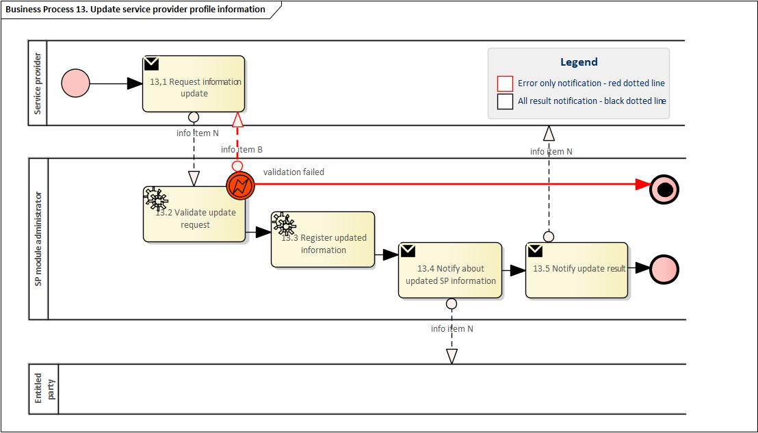



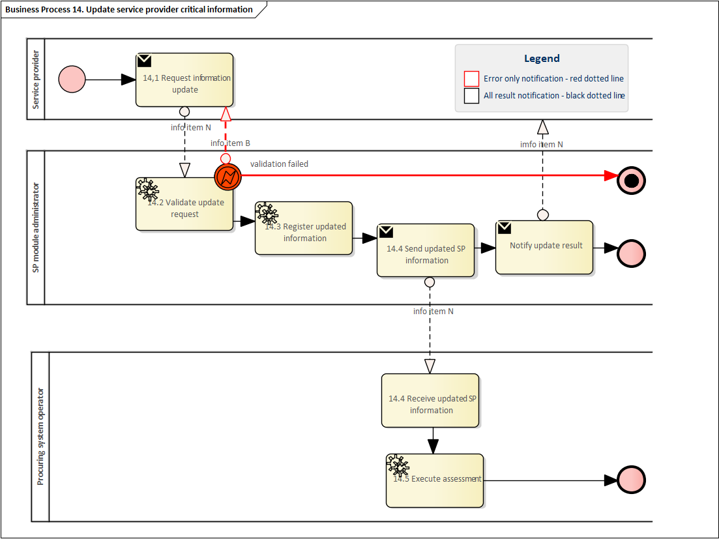

|  |  |  |  |  |  |
| --- | --- | --- | --- | --- | --- |
| ***Table III.14 – Procedure*** 14 | | | | | |
| ***Procedure name*** | | Table 19 De-registration of Service Provider | | | |
| ***Step No.*** | ***Step*** | ***Step description*** | ***Information producer (actor)*** | ***Information receiver (actor)*** | ***Information exchanged (IDs)*** |
| 14.1 | Request de-registration | The SP requests de-registration from one SP module from a certain de-registration date | Service provider | SP module administrator | AL – Service provider de registration request |
| 14.2 | Validate de-registration request | The SP module administrator validates the request and confirms that the request of de-registration is being processed or provides a meaningful information of an invalid request | SP module administrator | Service provider | B – Information on validation |
| 14.3 | *Execute de registration of SPUs and SPGs* | *The SP module administrator de-registers all the SPUs or SPGs of the service provider from the requested date* | SP module administrator | [not relevant] | [not relevant] |
| 14.4 | Execute de- registration of the SP | The SP module administrator proceeds to the de-registration of the SP from the requested date and notify the SP. | SP module administrator | [not relevant] | [not relevant] |
| 14.5 | Notify about de- registration | The SP module administrator notifies the service provider of the deregistration of the service provider from the requested date | SP module administrator | Service provider | AM - SP de registration notification |
| 14.6 | Notify about de- registration | The SP module administrator notifies entitled parties of the de registration of the service provider from a certain date and for specified products | SP module administrator | Entitled party | AM – SP de registration notificaion |

Diagram 14 – Procedure ‘De-registration of Service Provider’.

|  |  |  |  |  |  |
| --- | --- | --- | --- | --- | --- |
| ***Table III.15 – Procedure*** 15 | | | | | |
| ***Procedure name*** | | *Table 20 Suspension of Service Provider qualification by System Operator* | | | |
| ***Step No.*** | ***Step*** | ***Step description*** | ***Information producer (actor)*** | ***Information receiver (actor)*** | ***Information exchanged (IDs)*** |
| 15.1 | Request suspension of SP | The System Operator request suspension of the SP application(s) qualification(s) for a specific product with a meaningful reason. | System operator | SP module administrator | AN – SP- Product-SO suspension request |
| 15.2 | Validate SP suspension request | The SP module administrator validates the request. In case of an invalid request, a meaningful indication is provided. | SP module administrator | System operator | B – Information on validation |
| 15.3 | Register suspension | The SP module administrator suspends the relevant SP qualifications for the specific product.  The effect should be that SP will not be qualified to offer services from SPG or SPU where the SP application for specific product has been suspended. | SP module administrator | [not relevant] | [not relevant] |
| 15.4 | Notify SP | The SP module administrator notify the SP with the reason given by SO | SP module administrator | Service Provider | AO – SP- Product-SO suspension notification |
| 15.5 | (Conditional) Notify about SP suspension | (Conditional) Notify the final customer about SP suspension. | SP module administrator | Final customer | AO – SP- Product-SO suspension notification |
| 15.6 | Notify about SP suspension | Notifies all entitled parties of the SP suspension | SP module administrator | Entitled party | AO – SP- Product-SO suspension notification |

Diagram 15 – Procedure ‘Suspension of Service Provider qualification by System Operator’.

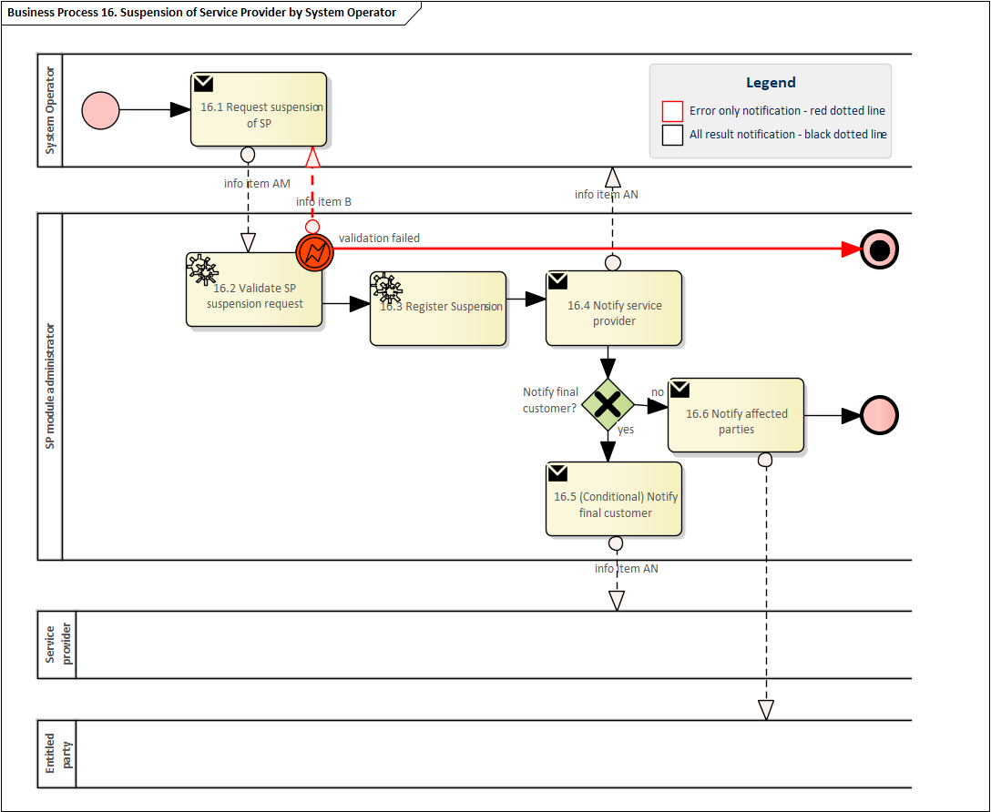

|  |  |  |  |  |  |
| --- | --- | --- | --- | --- | --- |
| ***Table III.16 – Procedure 16*** | | | | | |
| ***Procedure name*** | | *Table 21 Revocation of Service provider* | | | |
| ***Step No*** | ***Step*** | ***Step description*** | ***Information producer (actor)*** | ***Information receiver (actor)*** | ***Information exchanged (IDs)*** |
| 16.1 | Request revocation of SP | The Procuring System Operator requests the SP Module Administrator to revoke the qualification of a service provider and its SPU or SPG on one or more balancing or local products | Procuring System Operator | SP Module Administrator | AP – SP revocation request |
| 16.2 | Validate SP revocation request | The SP module administrator validates the revocation request and the entitlement of the requesting Procuring System Operator to trigger the update of the qualification status of the service provider and its SPU or SPG on balancing or local products. In case of an invalid request, a meaningful indication is provided. | SP Module Administrator | Procuring System Operator | B – Information on validation |
| 16.3 | Register revocation | The SP module administrator updates the qualification status of the service provider and its SPU or SPG on one or more balancing or local products. | SP Module Administrator | [not relevant] | [not relevant] |
| 16.4 | Notify about SP revocation | The SP module administrator notifies service provider about the update of the qualification status of service provider and its SPU or SPG on one or more balancing or local products of the service provider | SP Module Administrator | Service Provider | AQ - SP revocation notification |
| 16.5 | Notify about SP revocation | The SP module administrator notifies all entitled parties about the update of the qualification status of service provider and its SPU or SPG on one or more balancing or local products of the service provider | SP Module Administrator | Entitled party | AQ - SP revocation notification |

Diagram 16 – Procedure ‘Revocation of Service provider’.

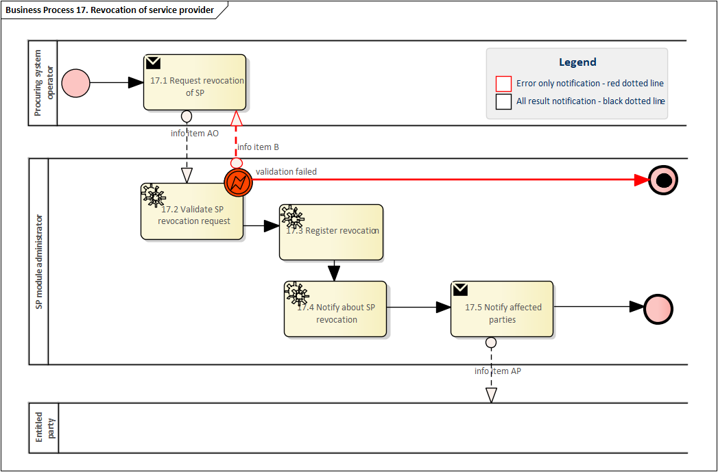

|  |  |  |  |  |  |
| --- | --- | --- | --- | --- | --- |
| ***Table III.17– Procedure*** 17 | | | | | |
| ***Procedure name*** | | Table 22 Reactivation of Service provider | | | |
| ***Step No.*** | ***Step*** | ***Step description*** | ***Information producer (actor)*** | ***Information receiver (actor)*** | ***Information exchanged (IDs)*** |
| 17.1 | Request re-activation of SP | Request a re-activation request for the suspended qualification(s) of the service provider for the specific product. | System Operator | SP Module Administrator | AR – SP-Product-SO reactivation request |
| 17.2 | Validate the re-activation request | The SP module administrator validates the re-activation request. In case of an invalid request, a meaningful indication is provided | SP Module Administrator | System Operator | B – Information on validation |
| 17.3 | Register re-activation | The SP module administrator removes the suspension of the qualification(s) of the service provider for the specific product.  The effect should be that SP will be qualified to offer services from SPG or SPU where the SP product application has previously been suspended. | SP Module Administrator | [not relevant] | [not relevant] |
| 17.4 | Notify SP | The SP module administrator notify the SP with the reason given by SO | SP module administrator | Service Provider | AS – SP-Product-SO reactivation notification |
| 17.5 | (Conditional) Notify about SP re-activation | (Conditional) Notify the final customer about SP re-activation. | SP module administrator | Final customer | AS – SP-Product-SO reactivation notification |
| 17.6 | Notify about SP re-activation | Notifies all entitled parties of the SP re-activation | SP module administrator | Entitled party | AS – SP-Product-SO reactivation notification |

Diagram 17 – Procedure ‘Reactivation of Service provider’.

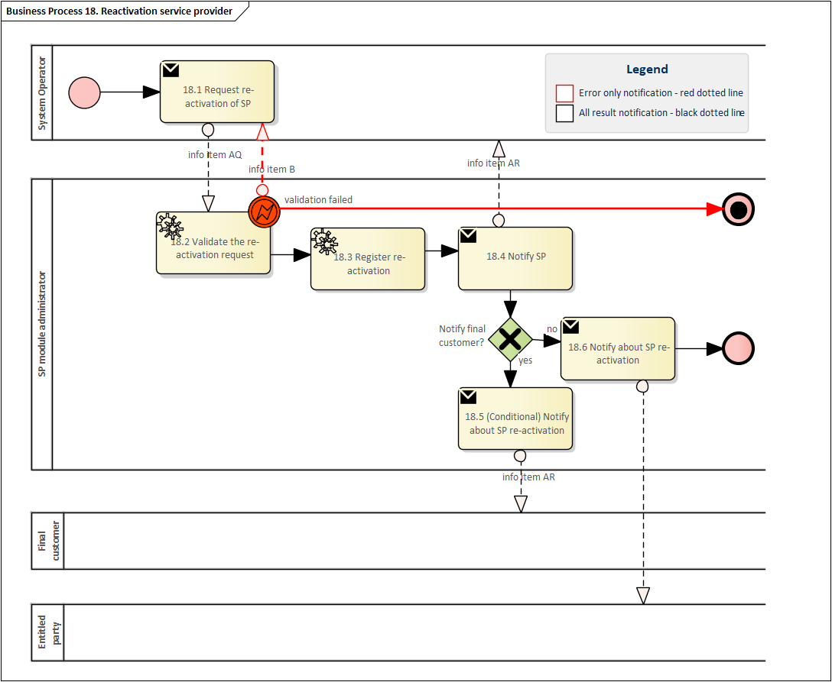











|  |  |  |  |  |  |
| --- | --- | --- | --- | --- | --- |
| ***Table III.18 – Procedure 18*** | | | | | |
| ***Procedure name*** | | Table SPU or SPG registration | | | |
| ***Step No.*** | ***Step*** | ***Step description*** | ***Information producer (actor)*** | ***Information receiver (actor)*** | ***Information exchanged (IDs)*** |
| 18.1 | Request SPU or SPG registration | The SP requests to register a new SPU or SPG in the flexibility information system. They may choose to use an existing identification code for the SPU or SPG if they have previously received an identification code that is valid according to the national terms and conditions. Otherwise, they can request and receive a new identification code during registration. | Service provider | SP module administrator | AT –SPU or SPG registration request | |
| 18.2 | Validate SPU or SPG registration request | The SP module administrator validates whether the service provider itself is not suspended and whether the request of the service provider is eligible for creating a unique identification for an SPU or SPG by the SP module administrator and provides a meaningful indication in case of an invalid request. | SP module administrator | Service provider | B – Information on validation | |
| 18.3 | Register SPU or SPG | The SP module administrator registers the SPU or SPG in the SP module. | SP module administrator | [not relevant] | [not relevant] | |
| 18.4 | Notify about successful SPU or SPG registration | The SP module administrator informs the service provider about the result of the requested registration of SPU or SPG | SP module administrator | Service provider | AU – SPU or SPG registration confirmation | |

Diagram 18 – Procedure ‘SPU or SPG registration’.

|  |  |  |  |  |  |
| --- | --- | --- | --- | --- | --- |
| ***Table III.19 – Procedure 19*** | | | | | |
| ***Procedure name*** | | Table SPU or SPG update | | | |
| ***Step No.*** | ***Step*** | ***Step description*** | ***Information producer (actor)*** | ***Information receiver (actor)*** | ***Information exchanged (IDs)*** |
| 19.1 | Request SPU or SPG update | The entitled party requests an update for the SPU or SPG providing relevant data. | Entitled party | SP module administrator | AV – SPU or SPG update request | |
| 19.2 | Validate SPU or SPG update request | The SP module administrator validates whether the request of the entitled party is eligible for updating SPU or SPG by the SP module administrator and provides a meaningful indication in case of an invalid request. | SP module administrator | Entitled party | B – Request  validation  information | |
| 19.3 | Register SPU or SPG update | The SP module administrator updates the SPU or SPG in the SP module of the FIS. | SP module administrator | [not relevant] | [not relevant] | |
| 19.4 | Notify about successful SPU or SPG update | The SP module administrator informs the service provider about the result of the requested update of SPU or SPG | SP module administrator | Service provider | AW – SPU or SPG update confirmation | |
| 19.5 | Notify updated SPU or SPG data | The SP module administrator informs entitled parties about the updated SPU or SPG data.  Note: A party entitled to do so may consider whether new product prequalification or product verification is needed due to the update of SPU or SPG data in accordance with the provisions of NC DR Art 22 (2) and national T&C for service providers. | SP module administrator | Entitled party | AX – SPU or SPG update notification | |

Diagram 19 – Procedure ‘SPU or SPG update’.

|  |  |  |  |  |  |
| --- | --- | --- | --- | --- | --- |
| ***Table III.20 – Procedure 20*** | | | | | |
| ***Procedure name*** | | Table SPU or SPG de-registration | | | |
| ***Step No.*** | ***Step*** | ***Step description*** | ***Information producer (actor)*** | ***Information receiver (actor)*** | ***Information exchanged (IDs)*** |
| 20.1 | Request SPU or SPG de-registration | The SP requests a de-registration for their SPU or SPG with providing their unique SP identification as well as the unique identification code for the SPU or SPG. | Service provider | SP module administrator | AY – SPU or SPG de-registration request | |
| 20.2 | Validate SPU or SPG de-registration request | The SP module administrator validates whether the service provider itself is registered and whether the request of the service provider is eligible for de-registering a unique identification for an SPU or SPG by the SP module administrator and provides a meaningful indication in case of an invalid request. | SP module administrator | Service provider | B – Request  validation  information | |
| 20.3 | Execute de-registration of SPU or SPG | The SP module administrator de-registers the SPU or SPG in the SP module. | SP module administrator | [not relevant] | [not relevant] | |
| 20.4 | Notify about successful SPU or SPG de-registration | The SP module administrator informs the service provider about the result of the requested de-registration of SPU or SPG | SP module administrator | Service provider | AZ - SPU or SPG de-registration confirmation | |

Diagram 20 – Procedure ‘SPU or SPG de-registration’.

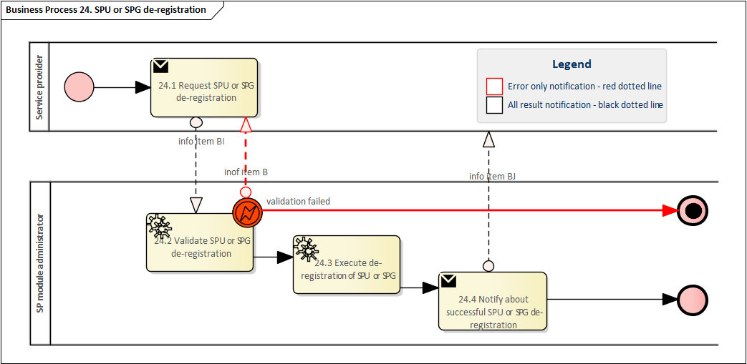

|  |  |  |  |  |  |
| --- | --- | --- | --- | --- | --- |
| ***Table III.21 – Procedure 21*** | | | | | |
| ***Procedure name*** | | Table SPU or SPG application | | | |
| ***Step No.*** | ***Step*** | ***Step description*** | ***Information producer (actor)*** | ***Information receiver (actor)*** | ***Information exchanged (IDs)*** |
| 21.1 | Request for product application | Service provider applies for products with their SPU or SPG as defined in the national terms and conditions for service providers. | Service provider | SP module administrator | BA– SPU or SPG product application request | |
| 21.2 | Validate product application request | SP module administrator validates the product application request. In case of an invalid request, a meaningful indication is provided. | SP module administrator | Service provider | B – Request  validation  information | |
| 21.3 | Register product application | SP module administrator registers the product application in the flexibility information system. | SP module administrator | [not relevant] | [not relevant] | |
| 21.4 | Send product application | SP module administrator informs the procuring system operator about pending product application. | SP module administrator | Procuring system operator | BA – SPU or SPG product application request | |
| 21.5 | [conditional]  Reconfigure the ICT infrastructure | Procuring system operator shall reconfigure and, if necessary, test the ICT infrastructure used to measure and control the delivery of a specific product (in accordance with Article 18.3 of the NCDR), in case the SP applies for the same product with a newly created SPU or SPG | Procuring system operator | [not relevant] | [not relevant] | |
| 21.6 | Validate product application for completeness | Procuring system operator validates that the product application is complete as defined in the national terms and conditions for service providers and provides a meaningful indication of the result. The result should include information about required prequalification process or verification process including temporary qualification. | Procuring system operator | SP module administrator | BB – SPU or SPG product application confirmation | |
| 21.7 | Register product application as complete | SP module administrator registers the product application as complete in the flexibility information system. | SP module administrator | [not relevant] | [not relevant] | |
| 21.8 | Notify about complete product application to service provider | SP module administrator notifies service provider about the complete product application.  Note: If product prequalification is required, the product prequalification responsible party will notify the service provider of the start of the product prequalification. If product verification is required, the service provider should have temporary qualification for the SPU or SPG, and they may start to utilize the SPU or SPG for providing demand response services. | SP module administrator | Service provider | BB – SPU or SPG product application confirmation | |
| 21.9 | Notify about complete product application to entitled parties | SP module administrator notifies entitled parties about the complete product application. Entitled parties include service provider and possibly connecting or impacted system operators. | SP module administrator | Entitled party | BC – SPU or SPG product application notification | |

Diagram 21 – Procedure ‘SPU or SPG application’.

|  |  |  |  |  |  |
| --- | --- | --- | --- | --- | --- |
| ***Table III.22 – Procedure 22*** | | | | | |
| ***Procedure name*** | | Table SPU or SPG suspension | | | |
| ***Step No.*** | ***Step*** | ***Step description*** | ***Information producer (actor)*** | ***Information receiver (actor)*** | ***Information exchanged (IDs)*** |
| 22.1 | Request SPU or SPG suspension | System operator requests temporary suspension of an SPU or SPG qualification for a product specifying a meaningful reason. | System Operator | SP Module Administrator | BD – SPU or SPG suspension request |
| 22.2 | Validate SPU or SPG suspension request | SP module administrator validates the suspension request. In case of an invalid request, a meaningful indication is provided. | SP Module Administrator | System Operator | B – Request  validation  information |
| 22.3 | Register updated status for the SPG or SPU | The SP module administrator suspends the SPG or SPU in the SP module for the requested product. | SP Module Administrator | [not relevant] | [not relevant] |
| 22.4 | Notify about SPU or SPG suspension | The SP module administrator notifies the service provider of the SPG or SPU about the suspension, including the reason for the suspension and which entity has initiated the suspension procedure. | SP Module Administrator | Service Provider | BE – SPU or SPG suspension notification |
| 22.5 | Notify about updated SPU or SPG information to entitled parties | The SP module administrator notifies entitled parties about the updated status of the SPG or SPU. | SP Module Administrator | Entitled party | BE – SPU or SPG suspension notification |

Diagram 22 – Procedure ‘SPU or SPG suspension’.

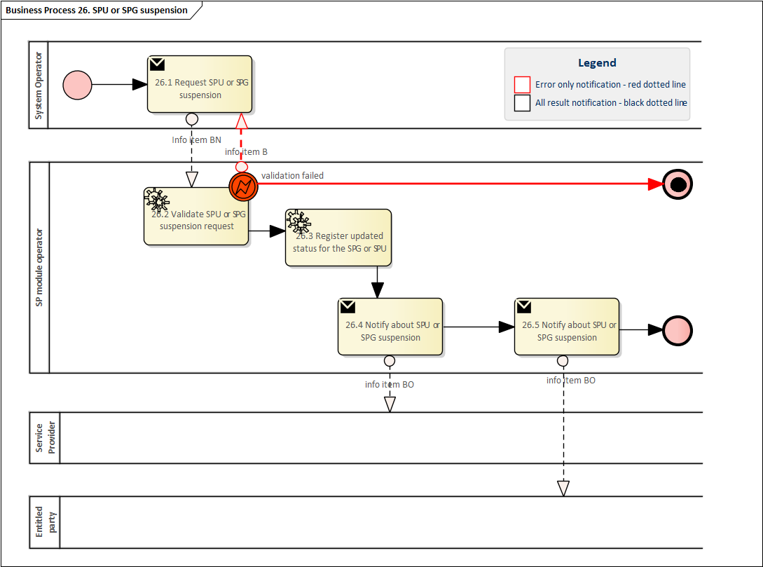

|  |  |  |  |  |  |
| --- | --- | --- | --- | --- | --- |
| ***Table III.23 – Procedure 23*** | | | | | |
| ***Procedure name*** | | Table 29 SPU or SPG re-activation | | | |
| ***Step No.*** | ***Step*** | ***Step description*** | ***Information producer (actor)*** | ***Information receiver (actor)*** | ***Information exchanged (IDs)*** |
| 23.1 | Request SPU or SPG re-activation | System operator requests re-activation of a suspended SPU or SPG for a product specifying the meaningful reason. | System Operator | SP Module Administrator | BF – SPU or SPG re-activation request |
| 23.2 | Validate SPU or SPG re-activation request | SP module administrator validates the re-activation request. In case of an invalid request, a meaningful indication is provided. | SP Module Administrator | System Operator | B – Request  validation  information |
| 23.3 | Register updated status for the SPU or SPG | The SP module administrator re-activates the SPG or SPU in the SP module for the requested product. | SP Module Administrator | [not relevant] | [not relevant] |
| 23.4 | Notify about SPU or SPG re-activation | The SP module administrator notifies the service provider of the SPG or SPU about the re-activation, including the reason for the re-activation. | SP Module Administrator | Service Provider | BG – SPU or SPG re-activation notification |
| 23.5 | Notify about updated SPU or SPG information | The SP module administrator notifies entitled parties about the updated status of the SPG or SPU. | SP Module Administrator | Entitled party | BG – SPU or SPG re-activation notification |

Diagram 23– Procedure ‘SPU or SPG re-activation’.

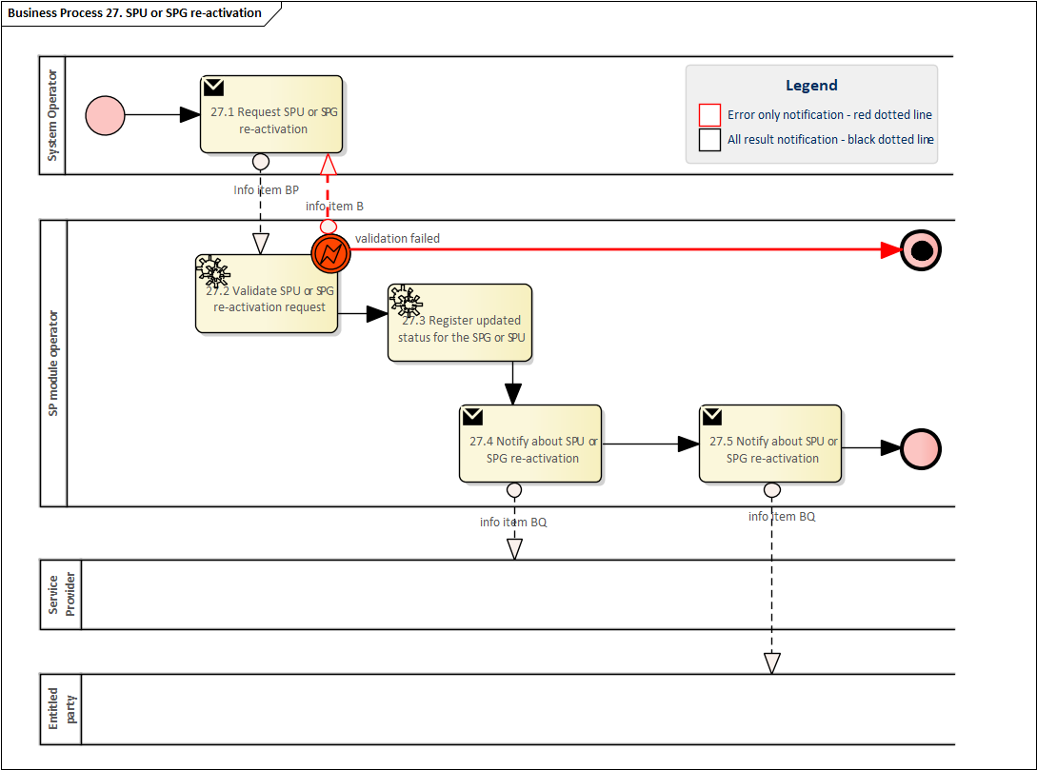

|  |  |  |  |  |  |
| --- | --- | --- | --- | --- | --- |
| ***Table III.24 – Procedure 24*** | | | | | |
| ***Procedure name*** | | Table 23 SPU or SPG grid prequalification | | | |
| ***Step No.*** | ***Step*** | ***Step description*** | ***Information producer (actor)*** | ***Information receiver (actor)*** | ***Information exchanged (IDs)*** |
| 24.1 | Request grid prequalification | The entitled party sends the request to the relevant Grid prequalification coordinator to coordinate Grid prequalification | Entitled party | Grid prequalification coordinator | BH - Grid prequalification request |
| 24.2 | Validate the grid prequalification request | The Grid prequalification coordinator validates the gird prequalification request. In case of an invalid request, a meaningful indication is provided | Grid prequalification coordinator | Entitled party | B – Information on validation |
| 24.3 | Execute grid prequalification coordination | Grid prequalification coordinator coordinates Grid prequalification process as described in national terms and conditions pursuant to Article 45 of NC DR | Grid prequalification coordinator | [not relevant] | [not relevant] |
| 24.4 | Notify grid prequalification results | The Grid prequalification coordinator sends the status of the completed Grid prequalification to the entitled parties | Grid prequalification coordinator | Entitled parties | BI - Grid prequalification result |

Note: This procedure covers parts of SPG as mentioned in the Article 27 (f) of NCDR and CU as mentioned in Article 28 (e) of NCDR.

Diagram 24 – Procedure ‘SPU or SPG grid prequalification’.

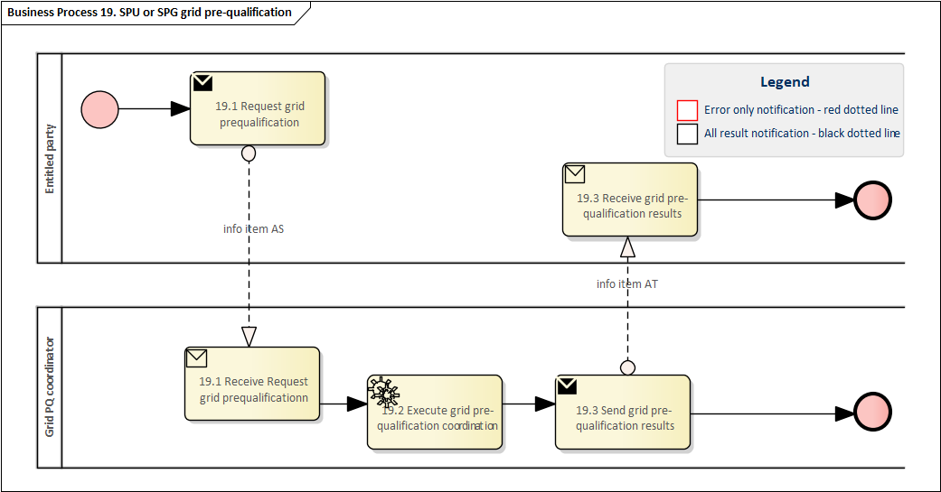

|  |  |  |  |  |  |  |
| --- | --- | --- | --- | --- | --- | --- |
| ***Table III.25 – Procedure 25*** | | | | | | |
| ***Procedure name*** | | Table 24 SPG or SPU product prequalification | | | | |
| ***Step No.*** | ***Step*** | ***Step description*** | ***Information producer (actor)*** | ***Information receiver (actor)*** | ***Information exchanged (IDs)*** |
| 25.1 | Notify information about the start of the product prequalification | The service provider is informed by the product prequalification responsible party that product prequalification according to national T&C has been started. | Product prequalification responsible party | Service provider | BJ – Information about the start of a product prequalification |
| 25.2a | [Conditional] Request technical data for the product prequalification | [Conditional] Product prequalification responsible party requests the technical data to the Service provider. | Product prequalification responsible party | Service provider | BK – Request technical data for product prequalification |
| 25.2b | Send technical data for the product prequalification | The service provider sends the required technical data for performing the product prequalification. | Service provider | Product prequalification responsible party | BL – Technical data for product prequalification |
| 25.2c | Send technical data for the product prequalification | The Service provider sends the technical data to the SP module administrator, who will store it | Service provider | SP Module administrator | BL – Technical data for product prequalification | | |
| 25.3 | Execute product prequalification | The product prequalification responsible party performs the product prequalification. The product prequalification responsible party makes use of the procedure General Access to SPG or SPU data to receive necessary data for prequalification. | Product prequalification responsible party | [not relevant] |  |
| 25.4a | [Conditional] Request activation test | Conditional: According to the national terms and conditions for Service Providers an activation test is requested by the product prequalification responsible party.  Note: Grid prequalification may be required before initiating the activation test. The connecting and impacted system operators are informed of the activation test. | Product prequalification responsible party | Activation test responsible | BM – Request activation test |
| 25.4b | Execute activation test | The activation test responsible party performs the activation test. | Activation test responsible party | Service provider | BN – Activation test |
| 25.4c | Send activation test result | The activation test responsible party sends the result of the activation test to the product prequalification responsible party | Activation test responsible party | Product prequalification responsible party | B – Request  validation  information |
| 25.5 | Notify the result of the product prequalification | The product prequalification responsible party notifies the entitled parties of the result of the product prequalification and confirms the SPU or SPG characteristics registered in the SP module. | Product prequalification responsible party | Entitled parties | BO – Product prequalification result |

Diagram 25 – Procedure ‘SPG or SPU product prequalification’

|  |  |  |  |  |  |
| --- | --- | --- | --- | --- | --- |
| ***Table III.26 – Procedure 26*** | | | | | |
| ***Procedure name*** | | *Table SPG or SPU product verification* | | | |
| **Step No.** | **Step** | **Step description** | **Information producer (actor)** | **Information receiver (actor)** | **Information exchanged (IDs)** |
| 26.1 | [Conditional] Notify information about the start of the product verification | [Conditional] The service provider is informed by the product verification responsible party that a product verification according to national terms and conditions has been started. | Product verification responsible party | Service provider | BP – Information about the start of a product verification |
| 26.2a | [Conditional] Request (aggregated) metered data for product verification | [Conditional] The product verification responsible party requests the (aggregated) metered data to perform the ex-post verification from the Quantification data aggregator. | Product verification responsible party | Quantification data aggregator | BQ – (aggregated) metered data request |
| 26.2b | Send (aggregated) metered data for produc verification | The Quantification data aggregator sends the requested (aggregated) metered data to perform the ex-post verification. | Quantification data aggregator | Product verification responsible party | AR – timeseries |
| 26.3 | Execute product verification | The product verification responsible party performs the product verification according to the national terms & conditions.  Note: According to national terms and conditions an activation test can be requested as defined in NC DR Art. 19 (3). | Product verification responsible party | [not relevant] |  |
| 26. 4 | Notify the result of the product verification | The product verification responsible party notifies the entitled parties of the result of the product verification and confirms the SPU and SPG characteristics registered in the SP module. | Product verification responsible party | Entitled parties | BS – product verification result |

Diagram 26 – Procedure ‘SPG or SPU product verification’.

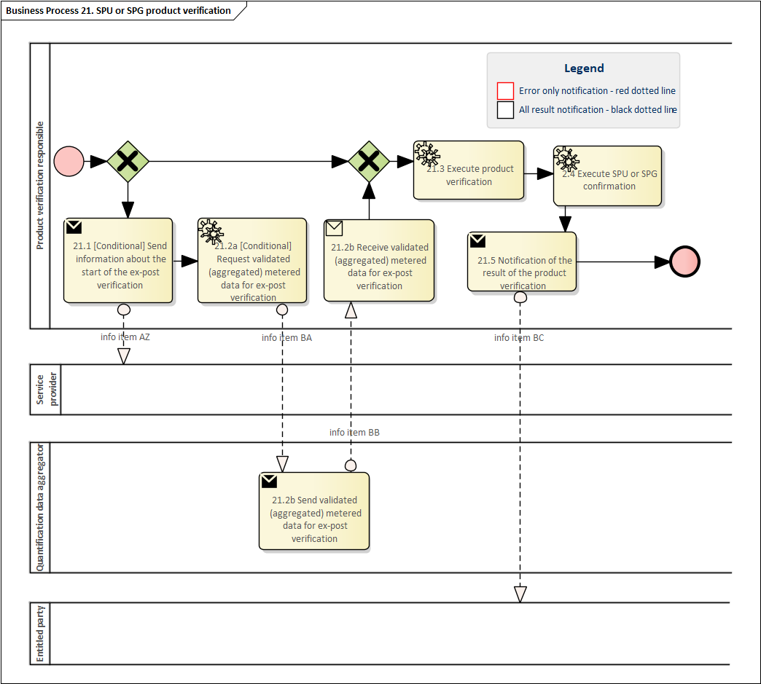

|  |  |  |  |  |  |
| --- | --- | --- | --- | --- | --- |
| ***Table III.27 – Procedure 27*** | | | | | |
| ***Procedure name*** | | Table 30 General access to SPU or SPG master data by an entitled party | | | |
| ***Step No.*** | ***Step*** | ***Step description*** | ***Information producer (actor)*** | ***Information receiver (actor)*** | ***Information exchanged (IDs)*** |
| 27.1 | Request for SPU or SPG master data | An entitled party requests to receive the SPU or SPG master data for one SPU or SPG which is registered in the Flexibility information system and linked to the requesting entitled party. | Entitled party | SP module administrator | BT – SPU or SPG master data request | |
| 27.2 | Validate SPU or SPG master data request | The SP module administrator validates whether the information request is permitted or not and provides a meaningful indication in case of an invalid request. | SP module administrator | Entitled party | B – Information on validation | |
| 27.3 | Notify SPU or SPG master data | The SP module administrator sends back the requested information from the flexibility information system. | SP module administrator | Entitled party | BU – SPU or SPG master data result | |

Diagram 27 – Procedure ‘General access to SPU or SPG master data by an entitled party’.

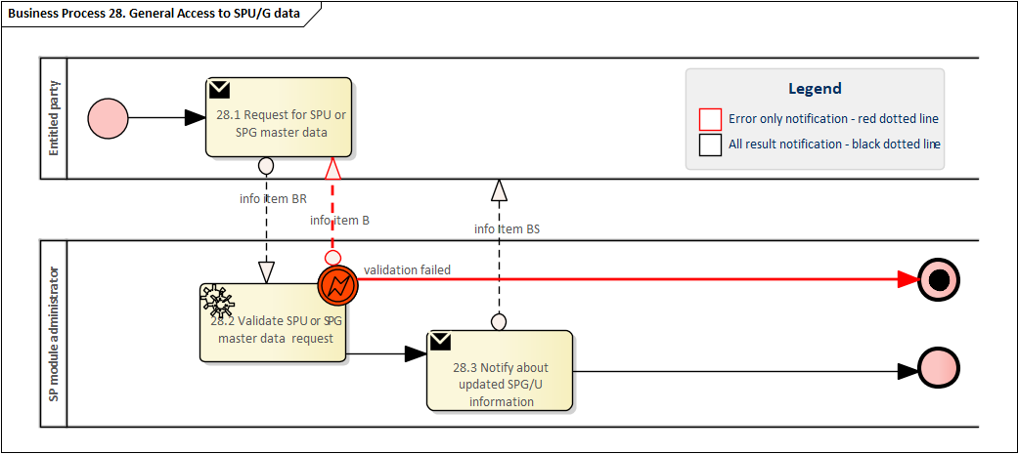

|  |  |  |  |  |  |
| --- | --- | --- | --- | --- | --- |
| ***Table III.28 – Procedure 28*** | | | | | |
| ***Procedure name*** | | Table 31 Bidding and activation of active power flexibility product | | | |
| ***Step No.*** | ***Step*** | ***Step description*** | ***Information producer (actor)*** | ***Information receiver (actor)*** | ***Information exchanged (IDs)*** |
| 28.1 | Send Bid[s] | The Service Provider makes their bid[s] available to the Service acquiring responsible party . | Service Provider | Service acquiring responsible party | BV - Bid information | |
| 28.2 | Validate received bid[s] message | Service acquiring responsible party validates the received bid[s] message. In case of an invalid message, a meaningful indication is provided | Service acquiring responsible party | [not relevant] | [not relevant] | |
| 28.3 | Execute selection of bids | Service acquiring responsible party executes necessary actions to trigger the selection of bid[s] and gets the related results. Note: selection takes place as a result from this step but is not described it might include different parties (automated by algorithm, etc.) | Service acquiring responsible party | [not relevant] | [not relevant] | |
| 28.4 | Notify of selected bid[s] to the Service Provider | The Service acquiring responsible party sends the information that the bid[s] of the service provider has been selected and the related information. | Service acquiring responsible party | Service Provider | BW– Selection of bid[s] | |
| 28.5a | [conditional] Send an activation message of selected bid[s] to the Service Provider | The Service acquiring responsible party sends the information that the bid[s] of the service provider has been activated and the related information. | Service acquiring responsible party | Service Provider | BX – Activation of bid[s] | |
| 28.5b | [conditional] Send a response to the activation message of selected bid[s] | The Service Provider sends a response with information on the implementation of the activation message. | Service Provider | Service acquiring responsible party | E- Response to activation of bid[s] | |
| 28.6 | [conditional] Notify Information about rejected bid | The Service acquiring responsible party notifies the service provider about the reason for their rejected bid | Service acquiring responsible party | Service Provider | BY – Rejected bid information | |



Diagram 28 – Procedure ‘Bidding and activation of active power flexibility product’.

|  |  |  |  |  |  |
| --- | --- | --- | --- | --- | --- |
| ***Table III.29 – Procedure 29*** | | | | | |
| ***Procedure name*** | | Table 32 (conditional) Temporary limits | | | |
| ***Step No.*** | ***Step*** | ***Step description*** | ***Information producer (actor)*** | ***Information receiver (actor)*** | ***Information exchanged (IDs)*** |
| 29.1 | Execute Temporary limit determination | The relevant system operator updates an existing or sets a new temporary limit on system elements, SPUs, SPGs or parts of SPGs | System operator | [not relevant] | [not relevant] | |
| 29.2 | Send temporary limit | The relevant system operator sends the determined temporary limit to the Temporary limit administrator | System operator | Temporary limit administrator | BZ - Temporary limit | |
| 29.3 | Notify temporary limit | The temporary limit administrator distributes the received temporary limit to the entitled party. Note: This might also require conditionally a feedback loop towards the System operator. | Temporary limit administrator | Entitled Party | BZ - Temporary limit | |

1. This procedure only needs to be mapped if the SPs as entitled parties are actively involved in this procedure based on the national Terms and conditions.

Diagram 29 – Procedure ‘(conditional) Temporary limits’.

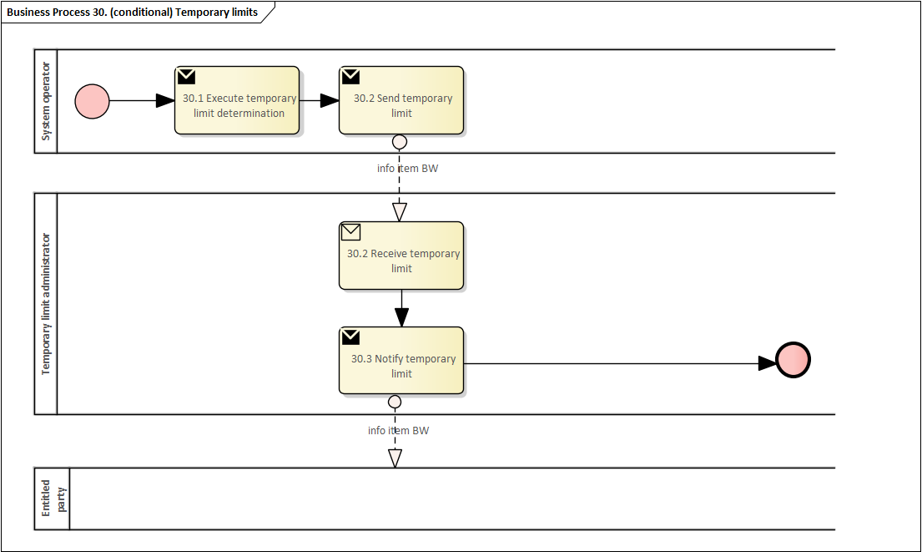

|  |  |  |  |  |  |
| --- | --- | --- | --- | --- | --- |
| ***Table III.30 – Procedure 30*** | | | | | |
| ***Procedure name*** | | Table Baseline data handling | | | |
| ***Step No.*** | ***Step*** | ***Step description*** | ***Information producer (actor)*** | ***Information receiver (actor)*** | ***Information exchanged (IDs)*** |
| 30.1 | [Conditional] Request necessary data to determine the baseline | The Baseline calculator requests the necessary data to determine the baseline from an entitled party defined in the national TC | Baseline calculator | Entitled party | CA –Baseline information request | |
| 30.1 | Send necessary data to determine the baseline | An entitled party defined in the national TC will acquire the relevant data used in the baselining method and send the data to the baseline calculator. | Entitled party | Baseline calculator | CB – Baseline information | |
| 30.2 | Determine baseline | The baseline calculator calculates or otherwise determines the baseline using the baselining method and the relevant data. | Baseline calculator | [not relevant] | [not relevant] | |
| 30.3 | Send the baseline | The baseline calculator sends the baseline to the baseline administrator. | Baseline calculator | Baseline administrator | AR –Timeseries | |
| 30.4 | Notify about the baseline data | The baseline administrator makes the baseline available to entitled parties. | Baseline administrator | Entitled parties | AR –Timeseries | |

**Note:** In case the entities involved in the procedure depend on the aggregation level of the baseline, the procedure should be mapped multiple times in the national reporting.

Diagram 30 – Procedure ‘Baseline data handling’.

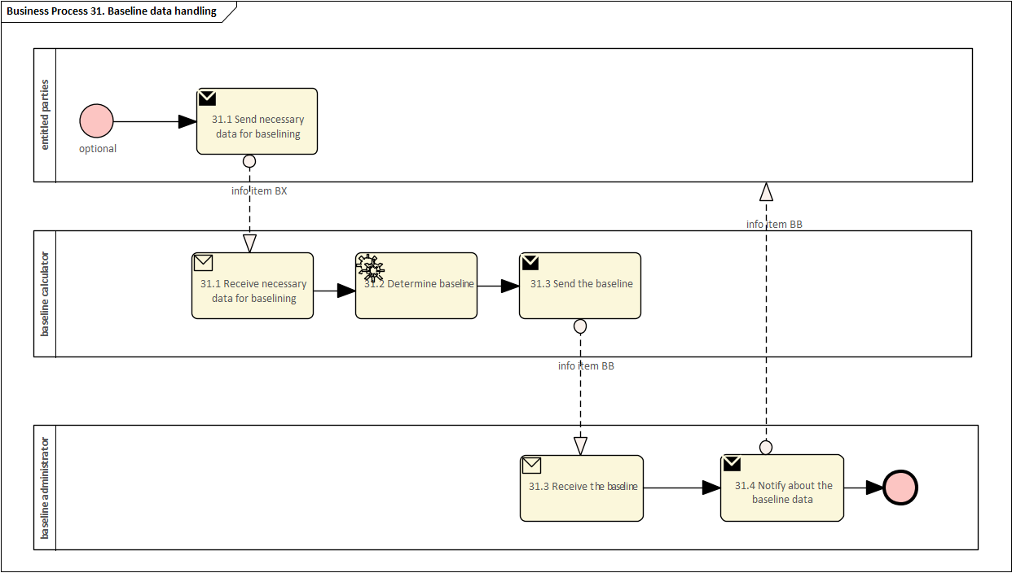

|  |  |  |  |  |  |
| --- | --- | --- | --- | --- | --- |
| ***Table III.31 – Procedure 31*** | | | | | |
| ***Procedure name*** | | Table Making measurement data available | | | |
| ***Step No.*** | ***Step*** | ***Step description*** | ***Information producer (actor)*** | ***Information receiver (actor)*** | ***Information exchanged (IDs)*** |
| 31.1a | [Conditional] Request validated historical metering and consumption data for CU | The quantification data aggregator requests validated historical metering and consumption data from the metered data administrator for the controllable units. | Quantification data aggregator | Metered data administrator | CC - “Metered data request” - defined as object H in the Implementing Regulation (EU) 2023/1162 |
| 31.1b | Validate request for validated historical metering and consumption data for CU | The metered data administrator validates the specified request for validated historical metering and consumption data and provides a meaningful indication in case of an invalid request. | Metered data administrator | Quantification data aggregator | B – Information on validation |
| 31.1c | Send validated historical metering and consumption data for CU | The metered data administrator makes available validated historical metering and consumption data to the quantification data aggregator. | Metered data administrator | Quantification data aggregator | CD - “Validated historical data” - defined as object F in the Implementing Regulation (EU) 2023/1162” |
| 31.2a | [Conditional]  Request for DMD data for CU | The quantification data aggregator requests DMD data from the dedicated measurement device data administrator for the controllable units. | Quantification data aggregator | Dedicated measurement device data administrator | CE – DMD data request |
| 31.2b | Validate request DMD data for CU | The dedicated measurement device data administrator validates the specified request for dedicated measurement device data and provides a meaningful indication in case of an invalid request. | Dedicated measurement device data administrator | Quantification data aggregator | B – Information on validation |
| 31.2c | Send DMD data for CU | A dedicated measurement device data administrator makes available DMD data to the quantification data aggregator. | Dedicated measurement device data administrator | Quantification data aggregator | AR – Timeseries |
| 31.3a | [Conditional]  Request for near-real-time metering and consumption data for CU | The quantification data aggregator requests near real-time metering and consumption data from the near real-time metering data administrator for the controllable units. | Quantification data aggregator | Near real-time metering data administrator | CF – near real-time metering and consumption data request |
| 31.3b | Validate request near real-time metering and consumption measurement data for CU | The near real-time metering data administrator validates the specified request for near real-time metering and consumption data and provides a meaningful indication in case of an invalid request. | Near real-time metering data administrator | Quantification data aggregator | B – Information on validation |
| 31.3c | Send near real-time metering and consumption data for CU | Near real-time metering data administrator makes available near real-time metering and consumption data to the quantification data aggregator. | Near real-time metering data administrator | Quantification data aggregator | AR – Timeseries |
| 31.4a | [Conditional]  Request calculated data for CU | The quantification data aggregator requests calculated data from the calculated data administrator for the controllable units. | Quantification data aggregator | Calculated data administrator | CG – Calculated data request |
| 31.4b | Validate request calculated data for CU | The calculated data administrator validates the specified request for calculated data and provides a meaningful indication in case of an invalid request. | Calculated data administrator | Quantification data aggregator | B – Information on validation |
| 31.4c | Send calculated data | The calculated data administrator makes calculated values available to the quantification data aggregator. | Calculated data administrator | Quantification data aggregator | AR – Timeseries |

In the procedure ‘Making measurement data available’ the steps for request (31.1.a, 31.2.a, 31.3.a and 31.4.a) and validate request (31.1.b, 31.2.b, 31.3.b and 31.4.b) may be omitted in cases where the respective data administrator provides the data proactively.

Diagram 31 – Procedure ‘Making measurement data available’.

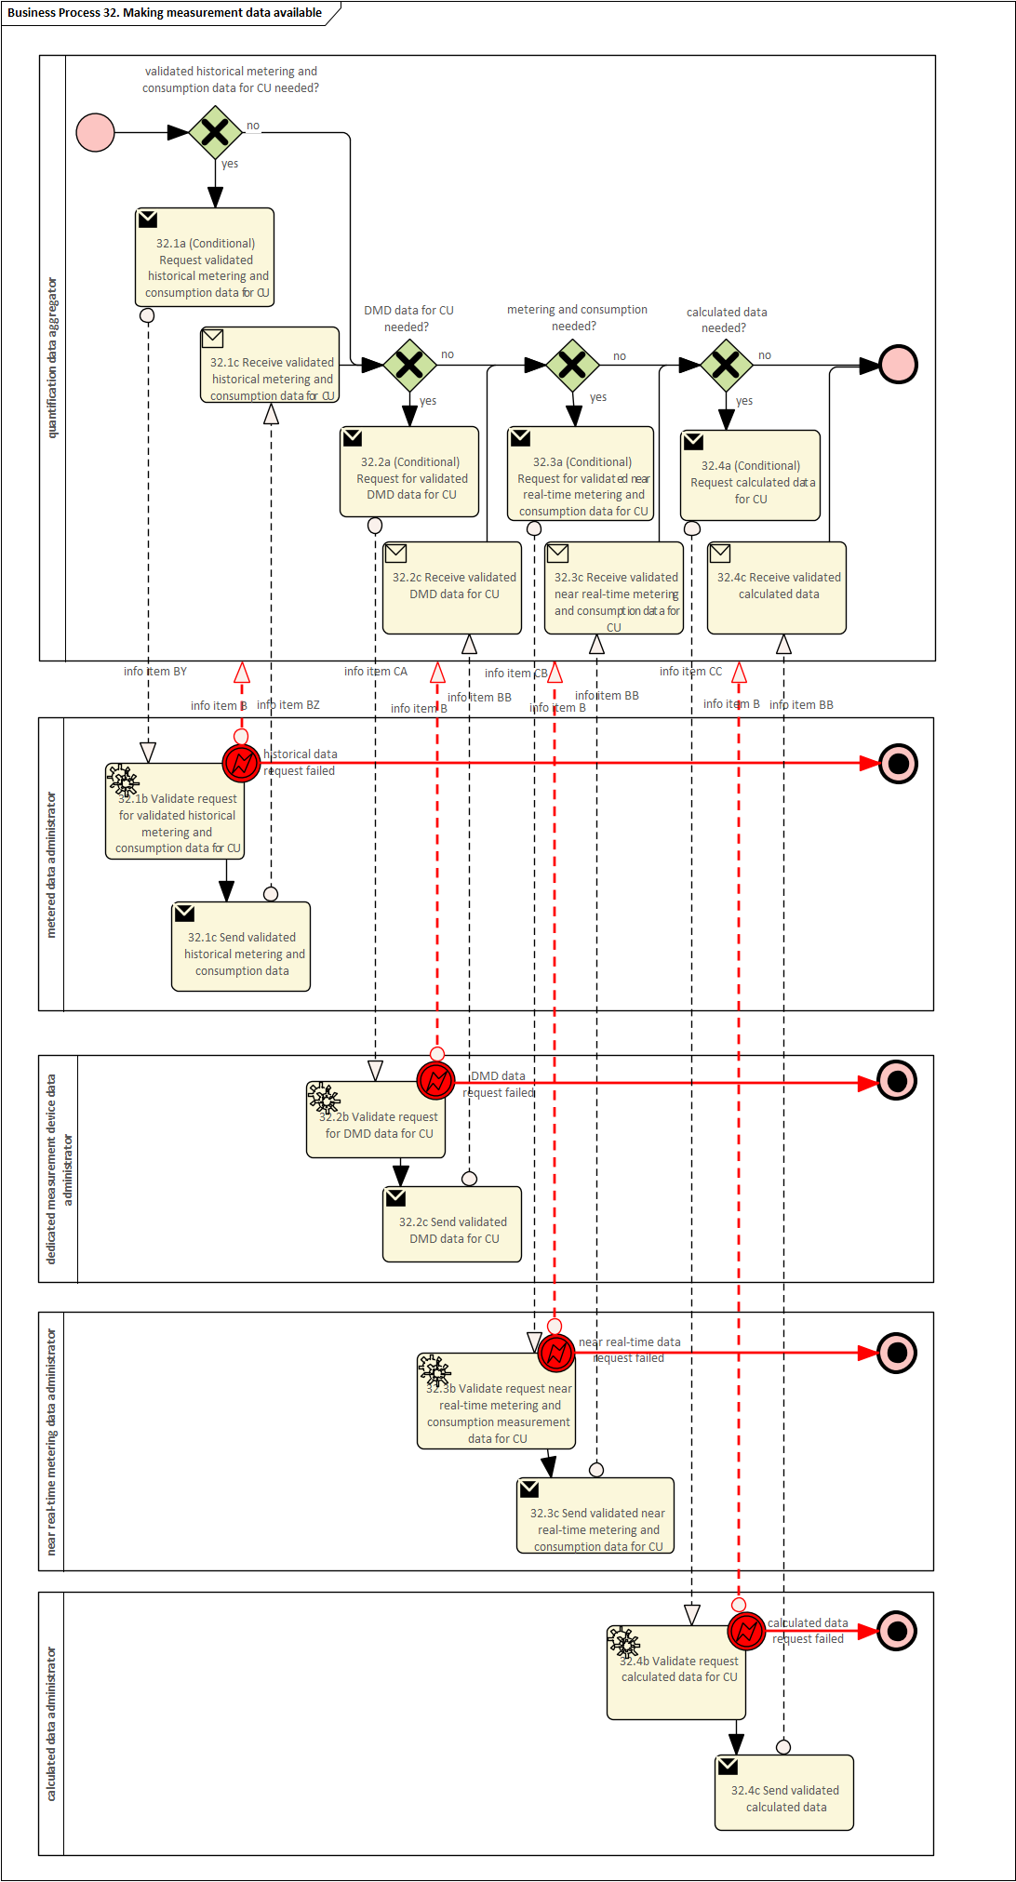

|  |  |  |  |  |  |
| --- | --- | --- | --- | --- | --- |
| ***Table III.32 – Procedure 32*** | | | | | |
| ***Procedure name*** | | Table Quantification | | | |
| ***Step No.*** | ***Step*** | ***Step description*** | ***Information producer (actor)*** | ***Information receiver (actor)*** | ***Information exchanged (IDs)*** |
| 32.1 | Request (aggregated) metered data for the activation period. | The Quantification responsible party requests the (aggregated) metered data from the quantification data aggregator for the activation period.  **Note:** The (aggregated) metered data might reflect different levels, e.g., individual CU, part of SPG or SPU, SPU, or SPGs, among others. | Quantification responsible party | Quantification data aggregator | BQ – (aggregated) metered data request |
| 32.2 | Validate (aggregated) metered data request. | The quantification data aggregator validates the specified (aggregated) metered data request and provides a meaningful indication in case of an invalid request. | Quantification data aggregator | Quantification responsible party | B – Information on validation |
| 32.3 | Send (aggregated) metered data | The quantification data aggregator makes available the requested (aggregated) metered data. | Quantification data aggregator | Quantification responsible party | AR – timeseries |
| 32.4 | Request baseline for the activation period | The Quantification responsible party requests the baseline from the baseline administrator.  **Note:** The baseline might reflect different aggregation levels, e.g., individual CU, part of SPG or SPU, SPU, or SPGs, among others. | Quantification responsible party | Baseline administrator | CH – Request Baseline |
| 32.5 | Validate baseline request | The baseline administrator validates the specified baseline request and provides a meaningful indication in case of an invalid request. | Baseline administrator | Quantification responsible party | B – Information on validation |
| 32.6 | Send baseline data | The baseline administrator sends back the requested baseline. | Baseline administrator | Quantification responsible party | AR – Timeseries |
| 32.7 | Quantify the requested volume | The Quantification responsible party determines the delivered volume. | Quantification responsible |  | [not relevant] |
| 32.8 | Notify the quantified volume | The Quantification responsible party makes available the result of the quantification. | Quantification responsible party | Entitled Party | AR – Timeseries |

In the procedure ‘Quantification the steps for request (32.1, 32.4) and validate request (32.2, 32.5) may be omitted in cases where the Baseline administrator or Quantification data aggregator provides the data proactively.

Diagram 32 – Procedure ‘Quantification’.

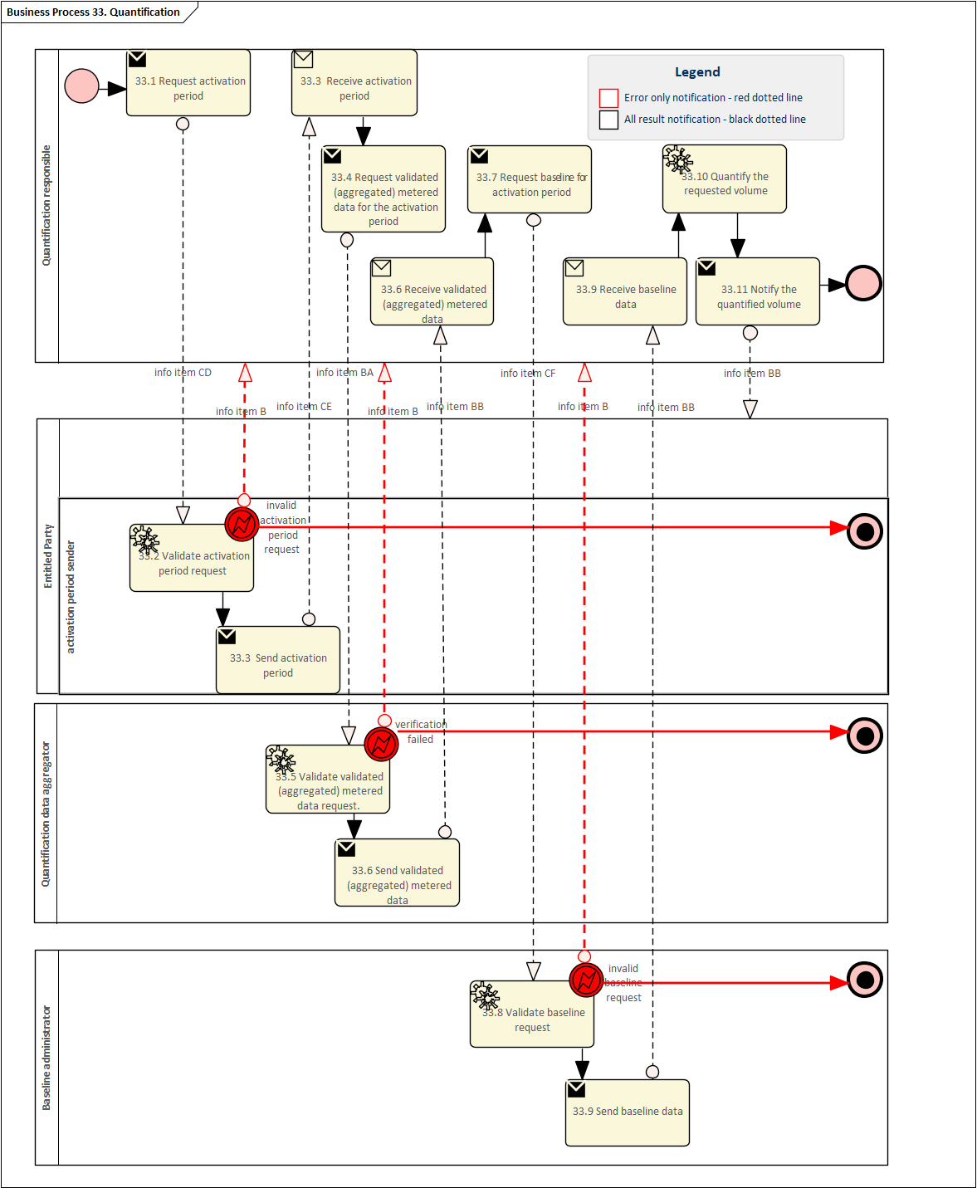

|  |  |  |  |  |  |
| --- | --- | --- | --- | --- | --- |
| ***Table III.33 – Procedure 32*** | | | | | |
| ***Procedure name*** | | Table 33 (Optional) Baseline validation | | | |
| ***Step No.*** | ***Step*** | ***Step description*** | ***Information producer (actor)*** | ***Information receiver (actor)*** | ***Information exchanged (IDs)*** |
| 32.1a | [Optional] Request activation period | Baseline validation responsible sends the request for activation period(s) as appropriate, and if applicable, for the validation process. | Baseline validation responsible party | Entitled party | CI – Activation period request | |
| 32.1b | Send activation period | The entitled party makes available the requested activation period(s). | Entitled party | Baseline validation responsible party | CJ – Activation period | |
| 32.2a | [Optional] Request information used in determining the baseline | Baseline validation responsible party requests the information used in determining the baseline, if applicable, and for a timeframe appropriate for the validation process. | Baseline validation responsible party | Entitled party | CA –Baseline information request | |
| 32.2b | Send baseline information | The entitled party makes available the requested information used in determining the baseline. | Entitled party | Baseline validation responsible party | CB – Baseline information | |
| 32.3a | [Optional] Request baseline | Baseline validation responsible party requests the baseline from the baseline admnistrator, if applicable, and for a timeframe appropriate for the validation process. | Baseline validation responsible party | Baseline administrator | CH – Request Baseline | |
| 32.3b | Send baseline | The baseline administrator makes available the requested baseline. | Baseline administrator | Baseline validation responsible party | AR –Timeseries | |
| 32.4a | [Optional] Request metered data | Baseline validation is responsible requests metered data, if applicable, and for a timeframe appropriate for the validation process. | Baseline validation responsible party | Quantification data aggregator | AR –Timeseries | |
| 32.4b | Send metered data | Quantification data aggregator makes available the requested metered data. | Quantification data aggregator | Baseline validation responsible party | AR – Timeseries | |
| 32.5 | Validate baseline | Baseline validation is responsible for validating the baseline using information and a timeframe appropriate for the validation process. | Baseline validation responsible party | [not relevant] | [not relevant] | |
| 32.6 | [Conditional] Notify baseline validation result | Baseline validation is responsible for notifying parties of the validation result as defined in the national TC for baselining methods. | Baseline validation responsible party | Entitled parties | CK – Baseline validation result | |

Diagram 33 – ‘(Optional) Baseline validation’.

|  |  |  |  |  |  |  |  |
| --- | --- | --- | --- | --- | --- | --- | --- |
| Table **Table IV - Information objects exchanged** | | | | | | | |
| ***Information exchanged, ID*** | | | ***Name of information*** | | ***Description of information exchanged*** | | |
| A | | | CU master data request | | Entitled party | | Entitled party which is issuing the information request |
| Request type | | CU master data list |
| B | | | Information on validation | | Validation result | | Information about the outcome of the validation step. |
| C | | | CU master data | | CU module | | Identification of the CU module |
| CU identification | | Nationally unique identification of the controllable unit |
| Service provider | | If the controllable unit is assigned to a service provider, European wide unique identification code of the service provider |
| Service delivery status | | An indication of the status of the CU. Non-exhaustive list of examples include:   * Planned * Operational * Suspended |
| Accounting point identifier(s) | | Identifier of the accounting point(s) the controllable unit has an impact on. |
| Locational information | | Conditional. Information about the location of the connection point of the CU. For example metering grid area. |
| Technical characteristics | | Information on technical characteristics of CU (e.g. minimum and maximum capacity of a battery, ramp-up times, etc.) |
| Data exchange standard implemented | | If applicable, the reference to the information exchange standard implemented by the controllable unit. |
| Customer connection point identifier | | Identifier of the customer connection point the controllable unit is connected to. |
| Metering configuration characteristics | | CU measured by one or more, or a combination of the following:   * DMD * smart metering system * Calculated data method   NCDR Article 12 – Settlement volumes determination |
|  | |  |
| D | | | CU registration request | | CU module | | Identification of a flexibility information system module |
| Identification | | Identification of the final customer |
| Registration date | | Date for when the registration shall be considered active |
| CU identification | | An existing unique identification code for the CU to be used in registration, if already available. |
| E | | | Permission validation request CU registration responsible party | | CU module | | Identification of a flexibility information system module |
|  | | |  | | Accounting point identifier | | Identifier of the accounting point(s) the controllable unit has an impact on. |
|  | | |  | | CU registration responsible party identification | | Unique identification code of the CU registration responsible up to the national T&C. |
|  | | |  | | Scope | | The scope of the permission requested to be given to the CU registration responsible party by the final customer |
| F | | | CU identification | | CU identification | | Nationally unique identification of the CU |
| Creation date | | Date of CU ID creation |
| G | | | CU de-registration request | | CU module | | Identification of a flexibility information system module at EU level. |
| CU identification | | Nationally unique identification of the controllable unit. |
| De-registration date | | Date for when the de-registration shall be considered active. |
| Reason | | Reason for the de-registration request. |
| H | | | CU de-registration notification | | CU identification | | Nationally unique identification of the CU |
| De-registration date | | Date for when the de-registration shall be considered active. |
| Reason | | Reason for the de-registration. |
| I | | | CU suspension request | | CU identification | | Nationally unique identification of the CU. |
| Suspension date | | Date for when the suspension shall be considered active. |
| Reason | | Reason for the suspension request. |
| J | | | CU suspension notification | | CU identification | | Nationally unique identification of the CU. |
| Suspension date | | Date for when the suspension shall be considered active. |
| Reason | | Reason for the suspension. |
| K | | | CU re-activation request | | CU identification | | Nationally unique identification of the CU. |
| Re-activation timestamp | | Timestamp from when the re-activation shall be active. |
| Reason | | Reason for the re-activation request. |
| L | | | CU re-activation notification | | CU identification | | Nationally unique identification of the CU. |
| Re-activation timestamp | | Timestamp from when the re-activation shall be active. |
| Reason | | Reason for the re-activation. |
| M | | | Service provider registration request | | Name | | Name of the service provider in a human readable and clearly identifiable form |
| SP module identification | | Identification of SP module |
| Service provider identification | | European wide unique identification code of the service provider to be used in registration. |
| N | | | Service provider identification information | | Service provider identification | | European wide unique identification code the service provider was registered with, if the service provider already has one. |
| SP module identification | | Identification of SP module |
| Sign-in information | | Credentials or other information to be used by the service provider to sign in into the SP module. |
| O | | | Service provider profile information | | Service provider identification | | European wide unique identification code of the service provider |
| License issued by the NRA | | If applicable |
| Name | | Name of the service provider in a human readable and clearly identifiable form |
| Contact information | | Comprising of at least, but not exclusive, phone number, email, and postal address |
| Settlement information | | Comprise of at least the VAT number or other identification if applicable, bank account and other related data |
| SP module identification | | Identification of the flexibility information system SP module with which the service provider intends to register. |
|  | |  |
| P | | | Service provider registration confirmation | | Service provider identification | | European wide unique identification code of the service provider |
| SP module identification | | Identification of the SP module |
| Date | | Date of when the registration has been completed |
| Q | | | Request for service provider qualification | | Procuring system operator identification | | Identification of the procuring system operator responsible for the qualification |
| Service provider identification | | European wide unique identification code of the service provider to be qualified |
| Product identification | | Identification of the product for which the service provider should be qualified |
| R | | | Service provider qualification status update | | Service provider identification | | European wide unique identification code of the service provider to be qualified |
| Procuring system operator identification | | Identification of the procuring system operator responsible for qualification |
| Product identification | | Identification of the product for which the service provider should be qualified |
| Qualification status | | Status of the qualification process |
| Reason | | Information complimenting the status |
| S | | | Contract termination request | | Final customer identification | | Identification of the final customer. |
| CU Identification | | Nationally unique identification of the CU. |
| Termination date | | Date of the requested contract termination |
| T | | | CU assignment data | | CU identification | | Nationally unique identification of the CU. |
| Service provider identification | | European wide unique identification code of the service provider |
| Date | | Date at which the CU should be assigned to or unassigned from the service provider |
| Type of assignment | | Type for the change. Eg. add CU to service provider, remove CU from service provider. |
| U | | | Accounting point entitlement notification | | Accounting point identification | | Identification of the accounting point |
| Final customer identification | | Identification of the final customer |
| Date | | Date at which the change takes places |
| Type of change | | Type for the change in accounting point entitlement. For example: lose entitlement, gain entitlement |
| V | | | CU removal notification | | CU identification | | Identification of the controllable unit |
| Date | | Date at which the CU is left without a service provider |
| Service provider identification | | European wide unique identification code of the service provider of the terminated contract. |
| W | | | Contract termination notification | | CU identification | | Identification of the respective controllable unit of the terminated contract. |
| Final customer identification | | Identification of the final customer of the terminated contract. |
| Service provider identification | | European wide unique identification code of the service provider of the terminated contract. |
| Termination date | | Date at which the contract termination takes places |
| X | | | New service provider contract request | | CU identification | | Nationally unique identifier of the CU. |
| Accounting point identification(s) | | Identifier(s) of the accounting point(s) for which the controllable unit has an impact. |
| Requested start data | | Requested date by the final customer for start of CU services by the service provider. |
| Y | | Up-front CU master data request | | CU identification | | Nationally unique identifier of the CU. |
| Service provider identification | | European wide unique identification code of the service provider |
| Request reason | | Reason for requesting access to CU master data. |
| Z | | Permission validation request service provider | | CU module | | Identification of a flexibility information system module |
|  | |  | | Accounting point identifier | | Identifier of the accounting point(s) the controllable unit has an impact on. |
|  | |  | | Service provider identification | | European wide unique identification code of the service provider |
|  | |  | | Scope | | The scope of the permission requested to be given to the service provider by the final customer |
| AA | | Up-front CU master data | | CU module | | Identification of the CU module |
| CU identification | | Nationally unique identification of the controllable unit |
| Service delivery status | | An indication of the status of the CU. Non-exhaustive list of examples include:   * Planned * Operational * Suspended |
| Accounting point identifier(s) | | Identifier of the accounting point(s) the controllable unit has an impact on. |
| Locational information | | Optional. Information about the location of the connection point of the CU. For example metering grid area. |
| Technical characteristics | | Information on technical characteristics of CU (e.g. minimum and maximum capacity of a battery, ramp-up times, etc.) |
| Data exchange standard implemented | | If applicable, the reference to the information exchange standard implemented by the controllable unit. |
| Customer connection point identifier | | Identifier of the customer connection point the controllable unit is connected to. |
| Metering configuration characteristics | | CU measured by one or more, or a combination of the following:   * DMD * smart metering system * Calculated data method   NCDR Article 12 – Settlement volumes determination |
|  | |  |
| AB | | | Contract confirmation | | No definition, free format | |  |
| AC | | | Technical registration request | | Start date | | The date requested by the new service provider to register on this CU. The date must be in the future of the request date. |
| CU identification | | The nationally unique identification of the CU that is intended to be registered or switched to a new service provider. |
| New service provider identification | | European wide unique identification code of the service provider |
| AD | | Contract registration notification to affected parties | | CU identification | | Nationally unique identification of the CU. |
|  | |  | | Handover date | | The date on which the present service provider no longer has the service responsibility for this CU (LOSS) or the date on which the new service provider will have the service responsibility for this CU (GAIN). |
| AE | | Registration result to SP | | CU identification | | Nationally unique identification of the CU. |
| New service provider identification | | European wide unique identification code of the service provider |
| Request result | | {if rejected} A code specifying (one of) the reason(s) for the rejection of the requested switch of service provider.  The codes are not specified in the Regulation, to be described in business standardisation. |
|  | |  | |  | |  |
|  | |  |
| AF | | | CU master data notification | | CU identification | | Nationally unique identification of the CU. |
| Handover date | | The date on which the present service provider no longer has the service responsibility for this CU (LOSS) or the date on which the new service provider will have the service responsibility for this CU (GAIN). |
| Accounting point identification(s) | | Identifier of the accounting points the controllable unit has an impact for. |
| New service provider identification | | European wide unique identification code of the service provider |
| AG | | Contract cancellation request | | No definition, free format | |  |
| AH | | Contract registration cancellation in CU module request | | Start date | | The date on which the new service provider was to take over the service for this CU. The date must be in the future. |
| CU identification | | Nationally unique identification of the CU. |
| New service provider identification | | European wide unique identification code of the service provider |
| AI | | Contract registration cancellation in CU module result | | CU identification | | Nationally unique identification of the CU. |
| New service provider identification | | European wide unique identification code of the service provider |
| Request result | | {if rejected} A code specifying (one of) the reason(s) for the rejection of the requested cancellation of service provider registration or switch request.  The codes are not specified in the Regulation, to be described in business standardisation. |
| AJ | | Cancellation notification to final customer | | No definition, free format | |  |
| AK | | Cancellation notification to affected parties | | Start date | | The date on which the new service provider was to take over the service for this CU. This date must be in the future |
| CU identification | | Nationally unique identification of the CU. |
|  | |  | |  | |  |
| AL | | | SP de registration request | | SP identification | | European wide unique identification code of the service provider |
| SP module identification << optional>> | | European wide unique identification of the SP module |
| De registration date | | Date for the de registration of the SP |
| AM | | | SP de-registration notification | | SP identification | | European wide unique identification code of the service provider |
| De registration date | | Date for the deregistration of the SP |
|  | | |  | |  | |  |
|  | |  |
|  | |  |
|  | | |  | |  | |  |
|  | |  |
|  | |  |
| AN | | SP-Product-SO Suspension request | | Service provider identification | | European wide unique identification code of the service provider to be qualified |
| Procuring system operator identification | | Identification of the procuring system operator responsible for qualification |
| Product identification | | Identification of the product for which the service provider should be suspended |
| From date-time | | Suspension from date and time |
| Status | | Status of the suspension |
| Reason | | Information complimenting the status |
| AO | | SP-Product-SO Suspension notification | | Service provider identification | | European wide unique identification code of the service provider to be qualified |
| Procuring system operator identification | | Identification of the procuring system operator responsible for qualification |
| Product identification | | Identification of the product for which the service provider is suspended |
| Suspension status | | Status of the suspension |
| Reason | | Information complimenting the status |
| AP | | | SP revocation request | | SP identification | | European wide unique identification code of the service provider |
| SP module identification << optional>> | | European wide unique identification of the SP module |
| Revocation date | | Date for when the revocation shall be considered active. |
| Reason | | Reason for the revocationrequest. |
| AQ | | | SP revocation notification | | SP identification | | European wide unique identification code of the service provider |
| SP module identification << optional>> | | European wide unique identification of the SP module |
| Revocation date | | Date for when the revocation shall be considered active. |
| Reason | | Reason for the revocation request. |
| AR | | | SP-Product-SO reactivation request | | Service provider identification | | European wide unique identification code of the service provider to be qualified |
|  | |  | | Procuring system operator identification | | Identification of the procuring system operator responsible for qualification |
|  | | Product identification | | Identification of the product to be reactivated |
|  | | From date-time | | Reactivation from date and time |
|  | | Status | | Status of suspension |
|  | | Reason | | Information complimenting the status |
| AS | | | SP-Product-SO reactivation notification | | Service provider identification | | European wide unique identification code of the service provider to be qualified |
|  | |  | | Procuring system operator identification | | Identification of the procuring system operator responsible for qualification |
|  | | Product identification | | Identification of the product for which the service provider is reactivated after suspension |
|  | | Suspension status | | Status of the suspension |
|  | |  | |  |
| AT | | | SPU or SPG registration request | | SP module | | Identification of a flexibility information system module at EU level. |
|  | | |  | | Preferred registration date | | Date for when the registration shall be considered active. |
| AU | | | SPU or SPG registration confirmation | | SP identification | | European wide unique identification code of the service provider |
|  | | |  | | Registration date | | Timestamp for when the registration was performed. |
|  | | |  | | SPU or SPG identification | | Unique identification of the SPU or SPG. |
| AV | | | SPU or SPG update request | | SP module | | Identification of a flexibility information system module |
|  | | |  | | SPU or SPG master data | | Information Object CL – SPU or SPG master data  Note: Only changed data is expected to be included in the request, other attributes are considered optional. |
|  | | |  | | Reason | | Reason or category for the update |
|  | | |  | | Information validity | | Period during which the updated data attributes are valid. |
| AW | | | SPU or SPG update confirmation | | SP module | | Identification of a flexibility information system module |
|  | | |  | | SPU or SPG master data | | Information Object CL – SPU or SPG master data |
|  | | |  | | SPU or SPG identification | | An existing unique identification code for the SPU or SPG to be used in registration. |
|  | | |  | | Update date | | Timestamp for when the update was registered in the SP module. |
| AX | | | SPU or SPG update notification | | SP module | | Identification of a flexibility information system module |
|  | | |  | | SPU or SPG master data | | Information Object CL – SPU or SPG master data |
|  | | |  | | Reason | | Reason or category for the update |
|  | | |  | | Information validity | | Period during which the updated data attributes are valid. |
| AY | | | SPU or SPG de-registration request | | SP module | | Identification of a flexibility information system module |
|  | | |  | | SP identification | | European wide unique identification code of the service provider |
|  | | |  | | SPU or SPG identification | | Unique identification of the SPU or SPG. |
|  | | |  | | De-registration date | | Date for when the de-registration shall be considered active. |
|  | | |  | | Reason | | (Optional) Reason for the de-registration request. |
| AZ | | | SPU or SPG de-registration confirmation | | SP identification | | European wide unique identification code of the service provider |
|  | | |  | | SPU or SPG master data | | Information Object CL – SPU or SPG master data  Note: Only changed data is expected to be included in the request, other attributes are considered optional. |
|  | | |  | | SPU or SPG identification | | Unique identification of the SPU or SPG. |
|  | | |  | | De-registration process date | | Date for when the de-registration has been processed. |
|  | | |  | | De-registration date | | Date for when the de-registration was performed. |
| BA | | | SPU or SPG product application request | | SP module | | Identification of a flexibility information system module at EU level. |
|  | | |  | | SP identification | | European wide unique identification code of the service provider |
|  | | |  | | SPU or SPG identification | | Unique identification of the SPU or SPG. |
|  | | |  | | Application date | | Date of the application |
|  | | |  | | Products | | Balancing or local product services to be provided with the SPU or SPG. |
|  | | |  | | SPU or SPG master data | | Information object CL – SPU or SPG master data |
|  | | |  | | Additional information | | Additional information for the product application request based on national terms and conditions in accordance with NC DR Art 18 (3). |
| BB | | | SPU or SPG product application confirmation | | SP module | | Identification of a flexibility information system module |
|  | | |  | | SP identification | | European wide unique identification code of the service provider |
|  | | |  | | Product prequalification responsible | | (Optional) Identification of the product prequalification responsible entity. |
|  | | |  | | SPU or SPG identification | | Unique identification of the SPU or SPG. |
|  | | |  | | Confirmation date | | Date of the confirmation that the application is complete. |
|  | | |  | | Products | | Balancing or local products to be provided. |
|  | | |  | | Participation condition | | Applicable prequalification or verification process for the SPU or SPG to participate in local or balancing service.  Note: In case of product verification, the SPU or SPG may have temporary qualification to participate. |
| BC | | | SPU or SPG product application notification | | SP module | | Identification of a flexibility information system module |
|  | | |  | | SP identification | | European wide unique identification code of the service provider |
|  | | |  | | Product prequalification responsible | | (Optional) Identification of the product prequalification responsible entity. |
|  | | |  | | SPU or SPG identification | | Unique identification of the SPU or SPG. |
|  | | |  | | Confirmation date | | Date of the confirmation that the application is complete. |
|  | | |  | | Products | | Balancing or local products to be provided. |
| BD | | | SPU or SPG suspension request | | SP module | | Identification of a flexibility information system module |
|  | | |  | | SPU or SPG identification | | European wide unique identification of the SP. |
|  | | |  | | Suspension date | | Timestamp when the suspension takes place. |
|  | | |  | | Product | | Balancing or local product for which the right to provide service is suspended. |
|  | | |  | | Reason | | Reason for the suspension |
| BE | | | SPU or SPG suspension notification | | SP module | | Identification of a flexibility information system module |
|  | | |  | | SPU or SPG master data | | Information Object CL – SPU or SPG master data |
|  | | |  | | System operator identification | | Identification of the system operator who suspended the SPU or SPG. |
|  | | |  | | SPU or SPG identification | | European wide unique identification of the SP. |
|  | | |  | | Suspension date | | Timestamp when the suspension takes place. |
|  | | |  | | Product | | Balancing or local product for which the right to provide service is suspended. |
|  | | |  | | Reason | | Reason for the suspension |
| BF | | | SPU or SPG re-activation request | | SP module | | Identification of a flexibility information system module |
|  | | |  | | SPU or SPG master data | | Information Object CL – SPU or SPG master data |
|  | | |  | | SPU or SPG identification | | Identification of the system operator who suspended the SPU or SPG. |
|  | | |  | | Re-activation date | | Timestamp when the re-activation takes place. |
|  | | |  | | Product | | Balancing or local product for which the re-activation of the right to provide service takes place. |
|  | | |  | | Reason | | (Optional) Reason for the re-activation |
| BG | | | SPU or SPG re-activation notification | | SP module | | Identification of a flexibility information system module |
|  | | |  | | System operator identification | | Identification of the system operator who suspended the SPU or SPG. |
|  | | |  | | SPU or SPG identification | | Identification of the system operator who suspended the SPU or SPG. |
|  | | |  | | Re-activation date | | Timestamp when the re-activation takes place. |
|  | | |  | | Product | | Balancing or local product for which the re-activation of the right to provide service takes place. |
|  | | |  | | Reason | | (Optional) Reason for the re-activation |
| BH | | | Grid prequalification request | | Reason | | Information specifying the reason for Grid prequalification request |
| Product | | Name of the product which are intended to be delivered and defined at national level |
| Identifier to reference object | | Unique identifier for the object of reference |
| BI | | | Grid prequalification result | | Status | | Possible statuses: “Grid prequalification not approved”, “Grid prequalification conditionally approved” or “Grid prequalification approved”; |
|  | | Identifier to reference object | | Unique identifier for the object of reference |
|  | | Reason | | Information complimenting the status (e.g., conditions for the Grid prequalification conditionally approved, reason for Grid prequalification not approved) |
|  | | Validity Period | | Start and end date during which the Grid prequalification will be valid |
| BJ | | | Information about the start of a product prequalification | | SP identification | | European wide unique identification code of the service provider |
| SPU or SPG identification | | Unique identification of the SPU or SPG. |
| Product identification | | Unique identification of the product. |
| BK | | | Request of technical data for product prequalification | | SP identification | | European wide unique identification code of the service provider |
|  | | |  | | SPU or SPG identification | | Unique identification of the SPU or SPG. |
|  | | |  | | Product identification | | Unique identification of the product. |
| BL | | | Technical data for product prequalification | | SP identification | | European wide unique identification code of the service provider |
| SPU or SPG identification | | Unique identification of the SPU or SPG. |
| Product identification | | Unique identification of the product. |
|  | | Technical prequalification data | | Technical data necessary for performing prequalification according to national terms and conditions |
| BM | | | Request activation test | | SP identification | | European wide unique identification code of the service provider |
| SPU or SPG identification | | Unique identification of the SPU or SPG. |
| Product identification | | Unique identification of the product. |
| BN | | | Activation test | | SP identification | | European wide unique identification code of the service provider |
| SPU or SPG identification | | Unique identification of the SPU or SPG. |
| Product identification | | Unique identification of the product. |
| Activation data | | Data for performing the activation test. |
| BO | | | Product prequalification result | | SP identification | | European wide unique identification code of the service provider |
| SPU or SPG identification | | Unique identification of the SPU or SPG. |
| Product identification | | Unique identification of the product. |
| Result | | Result about the outcome of the product prequalification. |
| Activation test result | | Information about the outcome of the potential activation test step. |
| BP | | | Information about the start of a product verification | | SP identification | | European wide unique identification code of the service provider |
| SPU or SPG identification | | Unique identification of the SPU or SPG. |
| Product identification | | Unique identification of the product. |
| Reason | | Reason for the product verification. |
| BQ | | (aggregated) metered data request | | Identifier to reference object | | Unique identifier for the object of reference |
| (optional) Type of reference object | | Specifies the type of the reference object. (e.g. CU, metering point, SPG or SPU, etc) |
| BB | | Information object BQ1- (aggregated) metered data specification |
| BQ1 | | (aggregated) metered data specification | | Start timestamp | | Start of the time interval covered by the data package |
| End timestamp | | End of the time interval covered by the data package |
| Direction | | Flow direction of the requested data. This can be either solely production, consumption, or combined. |
| Energy product | | Energy product of the requested data (e.g. active energy, re-active energy) |
| BR | | | Time series | | Type of timeseries | | Identification of the type of time series.(e.g. Baseline, calculated data, aggregated data. ) |
| Identifier to reference object | | Unique identifier for the object of reference |
| (optional) Type of reference object | | Specifies the type of the reference object. (e.g. CU, metering point, SPG or SPU, etc) |
| Creation timestamp | | Timestamp when the data package has been generated. |
| Energy product | | Energy product of the time series (for  example, active energy, re-active energy). |
| Start timestamp | | Start timestamp of the time series. |
| End timestamp | | End timestamp of the time series. |
| Unit | | The unit in which the quantities in field ‘Quantity’ have been stated. |
| For each interval | | |
| BS | | | Product verification result | | SP identification | | European wide unique identification code of the service provider |
| SPU or SPG identification | | Unique identification of the SPU or SPG. |
| Product identification | | Unique identification of the product. |
| Result | | Result about the outcome of the product verification. |
|  | | |  | |  | |  |
|  | |  |
|  | | |  | |  | |  |
|  | |  |
|  | |  |
|  | | |  | |  | |  |
|  | |  |
|  | |  |
|  | |  |
|  | | |  | |  | |  |
|  | |  |
|  | |  |
|  | |  |
|  | | |  | |  | |  |
|  | |  |
|  | |  |
|  | |  |
|  | | |  | |  | |  |
|  | |  |
|  | |  |
|  | |  |
|  | |  |
|  | | |  | |  | |  |
|  | |  |
|  | |  |
|  | |  |
|  | |  |
|  | | |  | |  | |  |
|  | |  |
|  | |  |
|  | |  |
|  | |  |
|  | |  |
|  | |  |
|  | | |  | |  | |  |
|  | |  |
|  | |  | |  |
|  | |  | |  |
|  | |  | |  |
|  | |  | |  |
|  | | |  | |  | |  |
|  | | |  | |  | |  |
|  | |  |
|  | |  | |  |
|  | |  | |  |
|  | |  | |  |
|  | |  | |  |
|  | | |  | |  | |  |
|  | |  |
|  | |  | |  |
|  | |  | |  |
|  | |  | |  |
|  | | |  | |  | |  |
|  | |  |
|  | |  |
|  | |  | |  |
|  | |  | |  |
|  | |  | |  |
|  | |  | |  |
|  | | |  | |  | |  |
|  | |  |
|  | |  |
|  | |  |
|  | |  |
|  | |  |
|  | | |  | |  | |  |
|  | |  |
|  | |  |
|  | |  | |  |
|  | |  | |  |
|  | |  | |  |
| BT | | | SPU or SPG master data request | | SP module | | Identification of a flexibility information system module |
| SPU or SPG identification | | An existing unique identification code for the SPU or SPG to be used in registration. |
| BU | | | SPU or SPG master data result | | SP module | | Identification of a flexibility information system module |
| SPU or SPG master data | | Information Object CL – SPU or SPG master data |
| BV | | Bid information | | Bid identification | | Unique identifier for the bid |
|  | |  | | (optional) Locational information | | Area for which the bid will have an effect. |
|  | |  | | BidTimeSeries information | |  |
|  | |  | | Identifier to reference object | | Unique identifier for the object of reference |
|  | |  | | (optional) Type of reference object | | Specifies the type of the reference object. (SPU, SPG, etc) |
|  | |  | | Creation timestamp | | Timestamp when the data package has been generated. |
|  | |  | | Start timestamp | | Start timestamp of the time series. |
|  | |  | | End timestamp | | End timestamp of the time series. |
|  | |  | | Unit | | The unit in which the quantities in field ‘Quantity’ have been stated. |
|  | |  | | Price Unit | | The unit in which the price in field ‘Price’ have been stated. |
|  | |  | | For each interval     |  |  | | --- | --- | | Start timestamp | Start timestamp of interval. | | End timestamp | End timestamp of interval. | | Direction | Up or Down | | Price | Price for the interval | | Quantity | Volume consumed or generated | | | |
|  | |  | | Divisibility | | Indicates whether a bid may be partially accepted |
|  | |  | | Product Type | | Type of a product |
|  | |  | | (optional) Capacity product for balancing or flexibility services | | Capacity product of the time series (for example, aFFR, mFRR, capacity for congestion management). |
|  | |  | | (optional) The start-up characteristics for SPU | | The start-up characteristics for SPU of the day |
| BW | | Selection of bid[s] | | Bid Identification | | Referring towards the identification from the bid information object. |
|  | |  | | Begin | | Begin of expected availability period. |
|  | |  | | End | | End of expected availability period. |
| BX | | Activation of bid[s] | | Bid identification | | Referring towards the identification from the bid information object. |
| Activation time period | |  |
| BidTimeSeries information | |  |
| Identifier to reference object | | Unique identifier for the object of reference |
| (optional) Type of reference object | | Specifies the type of the reference object. (e.g. CU, metering point, SPG or SPU, etc) |
| Creation timestamp | | Timestamp when the data package has been generated. |
| Energy product | | Energy product of the time series (for  example, active energy, re-active energy). |
| Start timestamp | | Start timestamp of the time series. |
| End timestamp | | End timestamp of the time series. |
| Unit | | The unit in which the quantities in field ‘Quantity’ have been stated. |
| (optional) Capacity product for balancing or flexibility services | | Capacity product of the time series (for example, aFFR, mFRR, capacity for congestion management). |
|  | | | (optional) The start-up characteristics for SPU | | The start-up characteristics for SPU of the day |
|  | | For each interval   |  |  | | --- | --- | | Start timestamp | Start timestamp of interval. | | End timestamp | End timestamp of interval. | | Direction | Up or Down | |  |  | | Quantity | Volume consumed or generated | | | |
| BY | | Rejected bid information | | Bid Identification | | Referring towards the identification from the bid information object. |
| Reason | | Reason for the rejection of the bid |
| BZ | | Temporary limit | | Identifier to reference object | | Unique identifier for the object of reference |
| (optional) Type of reference object | | Specifies the type of the reference object. (e.g. system element, SPU, SPG, parts of SPG) |
| Creation timestamp | | Timestamp when the data package has been generated. |
| Start timestamp | | Start timestamp of the time series. |
| End timestamp | | End timestamp of the time series. |
|  | |  |
| Unit | | The unit in which the quantities in field ‘Quantity’ have been stated. |
| For each interval   |  |  | | --- | --- | | Start timestamp | Start timestamp of interval. | | End timestamp | End timestamp of interval. | | Direction | For systems elements: Indicates the direction in which the increase of active power will direct the active power flow. .  For SPUs, SPGs or parts of SPGs:  Indicates the energy injection or withdrawal. | | Quantity | Value for the temporary limit | | | |
| CA | | Baseline information request | | Identifier to reference object | | Unique identifier for the object of reference |
|  | |  | | (optional) Type of reference object | | Specifies the type of the reference object. (e.g. CU, metering point, SPG or SPU, etc) |
|  | |  | | (optional) Start timestamp | | Start timestamp for the baseline information request |
|  | |  | | (optional) End Timestamp | | End timestamp for the baseline information request |
| CB | | Baseline information | | Identifier to reference object | | Unique identifier for the object of reference |
| (optional) Type of reference object | | Specifies the type of the reference object. (e.g. CU, metering point, SPG or SPU, etc) |
| Baselining method | | Unique identifier for the baselining method to be used |
| Baseline data | | All data required to specify the baseline including the baseline method used |
| CE | | | DMD data request | | Identifier to reference object | | Unique identifier for the object of reference |
| (optional) Type of reference object | | Specifies the type of the reference object. (e.g. CU, metering point, SPG or SPU, etc) |
| DMD data specification | | Information object CE1- DMD data specification |
| CE1 | | | DMD data specification | | Start timestamp | | Start of the time interval covered by the data package |
| End timestamp | | End of the time interval covered by the data package |
| Direction | | Flow direction of the requested data. This can be either solely production, consumption, or combined. |
| Energy product | | Energy product of the requested data (e.g. active energy, re-active energy) |
| CF | | near real-time metering and consumption data request | | Identifier to reference object | | Unique identifier for the object of reference |
| (optional) Type of reference object | | Specifies the type of the reference object. (e.g. CU, metering point, SPG or SPU, etc) |
|  | | | near real-time metering and consumption data specification | | Information object CF1- near real-time metering and consumption data specification |
| CF1 | | | near real-time metering and consumption data specification | | Start timestamp | | Start of the time interval covered by the data package |
| End timestamp | | End of the time interval covered by the data package |
| Direction | | Flow direction of the requested data. This can be either solely production, consumption, or combined. |
| Energy product | | Energy product of the requested data (e.g. active energy, re-active energy) |
| CG | | | Calculated data request | | Identifier to reference object | | Unique identifier for the object of reference |
| (optional) Type of reference object | | Specifies the type of the reference object. (e.g. CU, metering point, SPG or SPU, etc) |
| Calculated data specification | | Information object CG1- Calculated data specification |
| CG1 | | | Calculated data specification | | Start timestamp | | Start of the time interval covered by the data package |
| End timestamp | | End of the time interval covered by the data package |
| Direction | | Flow direction of the requested data. This can be either solely production, consumption, or combined. |
| Energy product | | Energy product of the requested data (e.g. active energy, re-active energy) |
| CH | | Baseline request | | Identifier to reference object | | Unique identifier for the object of reference |
|  | |  | | (optional) Type of reference object | | Specifies the type of the reference object. (e.g. CU, metering point, SPG or SPU, etc) |
|  | |  | | Period start | | Start of the period for which the baseline is requested. |
|  | |  | | Period end | | End of the period for which the baseline is requested. |
| CI | | Activation period request | | Identifier to reference object | | Unique identifier for the object of reference |
| (optional) Type of reference object | | Specifies the type of the reference object. (e.g. CU, metering point, SPG or SPU, etc) |
| Identification of bid | | Unique identification of bid. |
| CJ | | | Activation period | | Identifier to reference object | | Unique identifier for the object of reference |
| (optional) Type of reference object | | Specifies the type of the reference object. (e.g. CU, metering point, SPG or SPU, etc) |
|  | | | Begin | | Begin of considered period. |
|  | | End | | End of considered period. |
|  | | |  | |  | |  |
|  | |  |
|  | |  |
|  | |  |
|  | |  | |  | |  |
|  | |  |
|  | |  |
|  | |  |
| CK | | Baseline validation result | | Identifier to reference object | | Unique identifier for the object of reference |
| (optional) Type of reference object | | Specifies the type of the reference object. (e.g. CU, metering point, SPG or SPU, etc) |
| Baseline validation result | | Information object B - Information on validation. |
|  | | |  | |  | |  |
|  | | |  | |  | |  |
|  | | |  | |  | |  |
| CL | | SPU or SPG master data | | SP identification | | European wide unique identification code of the service provider | |
| SPU or SPG identification | | An existing unique identification code for the SPU or SPG. Optional when requesting new identification code during registration of a new SPU or SPG. | |
|  | |  | |
| Each Status value has a timestamp for when the status was assigned.   |  |  | | --- | --- | | Status value | Status of the SPU or SPG. The SPU or SPG could have several different types of statuses defined in national terms and conditions (examples of such types include but are not limited to prequalification status, product verification status, SP’s own status) and related to each balancing or local product. The status attribute could be changed by different roles in different processes. Not all roles have the right to update all types of statuses. | | Start timestamp | Start timestamp of the recorded status | | | | |
| Technical characteristics | | Technical characteristics of the SPU or SPG, including active and possibly reactive power characteristics of the SPU or SPG. | |
|  | |  | |
| SPU or SPG data attributes | | Other data attributes for the SPU or SPG as defined in the national terms and conditions. | |
| For each CU assigned to the SPU or SPG   |  |  | | --- | --- | | CU identification | Nationally unique identification of the CU. assigned to the SPU or SPG. | | Start timestamp | Start timestamp of the period when the CU is assigned to the SPU or SPG | | End timestamp | End timestamp of the period when the CU is assigned to the SPU or SPG | | | | |
|  | | | |
|  | | | SPU and SPG master data | | Product identification | | Unique identification of the product(s) for which the SPU or SPG is (temporarily) prequalified. |
| CK | | | Response to activation of bid[s] | | Received Activation | | Reference towards the received ‘BU - Activation of bid[s]’ |
|  | | |  | | Implementation information | | Information on the implementation of the activation message |
|  | | |  | |  | |  |
|  | | |  | |  | |  |
|  | | |  | |  | |  |
|  | | |  | |  | |  |
|  | | |  | |  | |  |
|  | | |  | |  | |  |
|  | | |  | |  | |  |
|  | | |  | |  | |  |
|  | | |  | |  | |  |

1. Meaningful indication means here a human understandable information about the reason for the rejection.